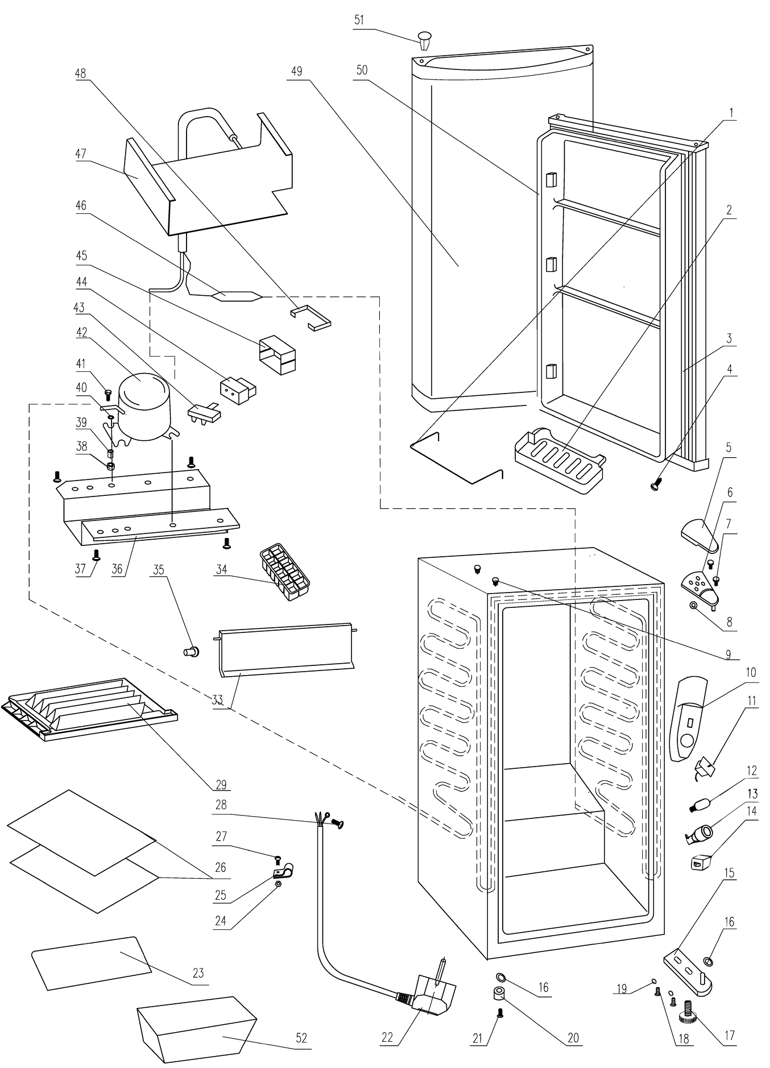
Item | FHE Part Code | Description
1 | DC-122Q-SSBH | Stainless Steel Bottle Holder 1.06.00.0000029
2* | DC-122Q-DS | Door Shelf 1.22.00.2000024
3* | DC-122Q-DG | Door Gasket 1.21.00.0000299
5 | DC-122Q-UHC | Upper Hinge Cover 1.02.00.0003261
6* | DC-122Q-UH | Upper Hinge 1.06.00.0000439
7 |  | Upper Hinge Screw
8 |  | Upper Hinge Washer
9 | DC-122Q-UHP | Upper Hinge Plug
10 | 1.02.00.0000421 | Thermostat Cover
11* | DC-122Q-Thermostat | Thermostat wpfe24 1.63.00.0000055
12* | DC-122Q-TK | Thermostat Knob
13* | DC-122Q-DPB | Defrost Push Button
14* | 1.19.00.0000004 | Door Switch
15* | DC-122Q-BH | Bottom Hinge 1.06.00.0000483
16 | 1.02.00.0000111 | Lock Washer
17 | 1.02.00.0000215 | Adjustable Foot
18 |  | Lower Hinge Screw
19 |  | Lower Hinge Washer
20 | DC-122Q-Foot | Foot 1.02.00.0000264 Also Suit DC-80F
21 | DC-122Q-FFS | Fixed Foot Screw
22 | 1.19.00.0000193 | Power Cord
23* | DC-122Q-SSS | Short Shelf Support
24 |  | Shelf Support Screw
25 | DC-122Q-WSC | Wire Shelf Clip
26* | DC-122Q-SS | Long Shelf Support 1.67.00.2000232
27 |  | Shelf Support Screw
28 |  | Grounding Screw
29 | 1.02.00.0000108 | Drip Tray
33 | 1.02.00.0000136 | Evaporator Door
34* | 1.02.00.0000082 | Ice Cube Tray
35 | 1.25.00.0000039 | Upper Door Hinge Pin

*Wearable parts
Item | FHE Part Code | Description
36 | 1.05.00.0000019 | Compressor Support
37 |  | Compressor Support Screw
38 |  | Compressor Mounting Washer
39 | DC-122Q-STS | Suction Tube Sleeve
40 |  | Compressor Mounting Washer
41 |  | Compressor Mounting Screw
42* | DC-122Q-Compressor | Compressor 1.05.00.0000553 QV43Y R600a
43* | DC-122Q-TP | Thermal Protector
44* | DC-122Q-SR | Start Relay
45 | DC-122Q-RC | Relay Cover
46 | 1.25.00.0000154 | Filter Drier
47* | 1.65.00.0000016 | Evaporator
48 | DC-122Q-RCR | Relay Cover Retainer
49 | DC-122Q-Door | Door 1.51.00.0001590
50 | DC-122Q-DL | Door Liner
51 | 1.02.00.1001274 | Upper Hinge Plug
52* | DC-122Q-Crisper | Crisper 1.02.00.5000112

