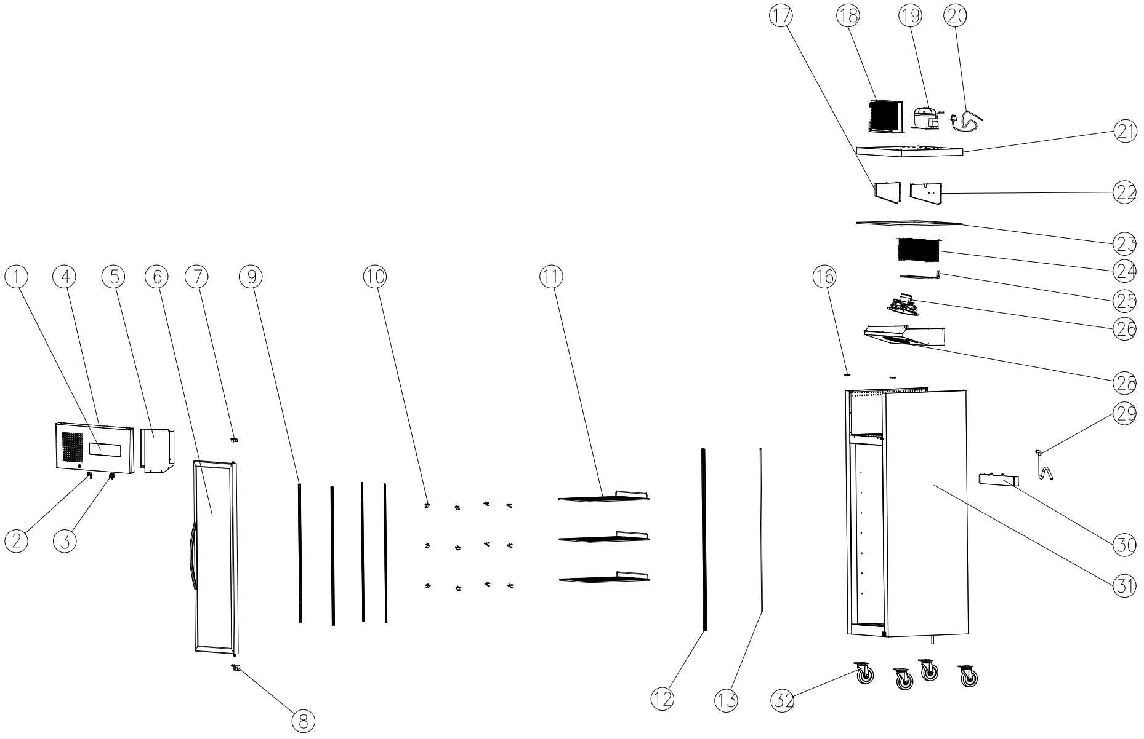
Item |  | FHE Part Code | Description | Qty | Remark
1* |  | SUC-SUF-TCK | Touch Controller Kit | 1
2 |  | SUC/SUF-Key | Key & Lock Assembly | 1
3* |  | SUCG500-FS | Fan Switch | 1
4 |  | SUCG500B-TP | Top Panel Black | 1
5 |  | SUCG500-TCPP | Temperature Control Protection Panel | 1
6* |  | SUCG1000B-RD-X | Right Glass Door Black | 1
7* |  | SUCG1500-TRDH-X | Top Door Hinge | 1
8* |  | SUCG1500-BRDH-X | Bottom Door Hinge | 1
9 |  | SUCG500-KSS | K-type Seal Strip | 4
10 |  | SUF600-20 | Shelf K Clip | 12
11* |  | SUFG500-2 | Wire Shelf 480mm X 530mm | 3
12* |  | SUFG500-LL-3000K | LED Light 3000K | 2
13 |  | SUFG1000-20 | LED Light Strip | 2
16* |  | SUCG500-TCH | Top Cover Hinge | 1
17 |  | SUCG500-LEB | Left Evaporator Baffle | 1
18* |  | SUF500-23 | Condenser 3R10K320L | 1

Item |  | FHE Part Code | Description | Qty | Remark
19* |  | NEU2168GK | Compressor R404a | 1
20 |  | SUCG500-PC | Power Cord | 2
21 |  | SUCG500-LCP | Lower Cover Plate | 1
22 |  | SUCG500-REB | Right Evaporator Baffle | 1
23 |  | SUCG500-PIC | PE Insulation Cotton | 1
24* |  | SUF500-35 | Evaporator 5R6K320L | 1
25* |  | SUF500-HGD | Hot Gas Defrost Heater/Heating Element | 1
26* |  | SUCG500-EFMA | Evaporator Fan Motor Assembly | 1
28 |  | SUCG500-EFC | Evaporator Fan Cover | 4
29 |  | SUCG500-DP | Drain Pipe | 12
30 |  | SUCG500-EWT | Water Tray For Evaporator | 3
31 |  |  | Cabinet Body | 1
32 |  | SUF1000-NC-X | Normal Castor | 4
 |  | SUF1000-BC-X | Brake Castor
 |  | SUF1000-PH | Pan/Drain Heater
 |  | Drier-1 | DRIER LIQUID LINE DML032S 1/4 SOLDER

*Wearable parts
Item |  | FHE Part Code | Description | Qty | Remark
 |  | SUCG1000-DG-X | Door Gasket
 |  | FAN-23 | Square EBM Style 34W Universal RF516A
 |  | SUFG500B-CF | Condenser Filter 340mm X 270mm
 |  | SUFG500B-CFB | Condenser Fan Blade
 |  | SUFG500B-CFBC | Condenser Fan Blade Cover
 |  | SUFG500-DHT-X | Door Heater Transformer
 |  | SUFG500-PLK | Plastic Lock Keeper Suit SUFG500

