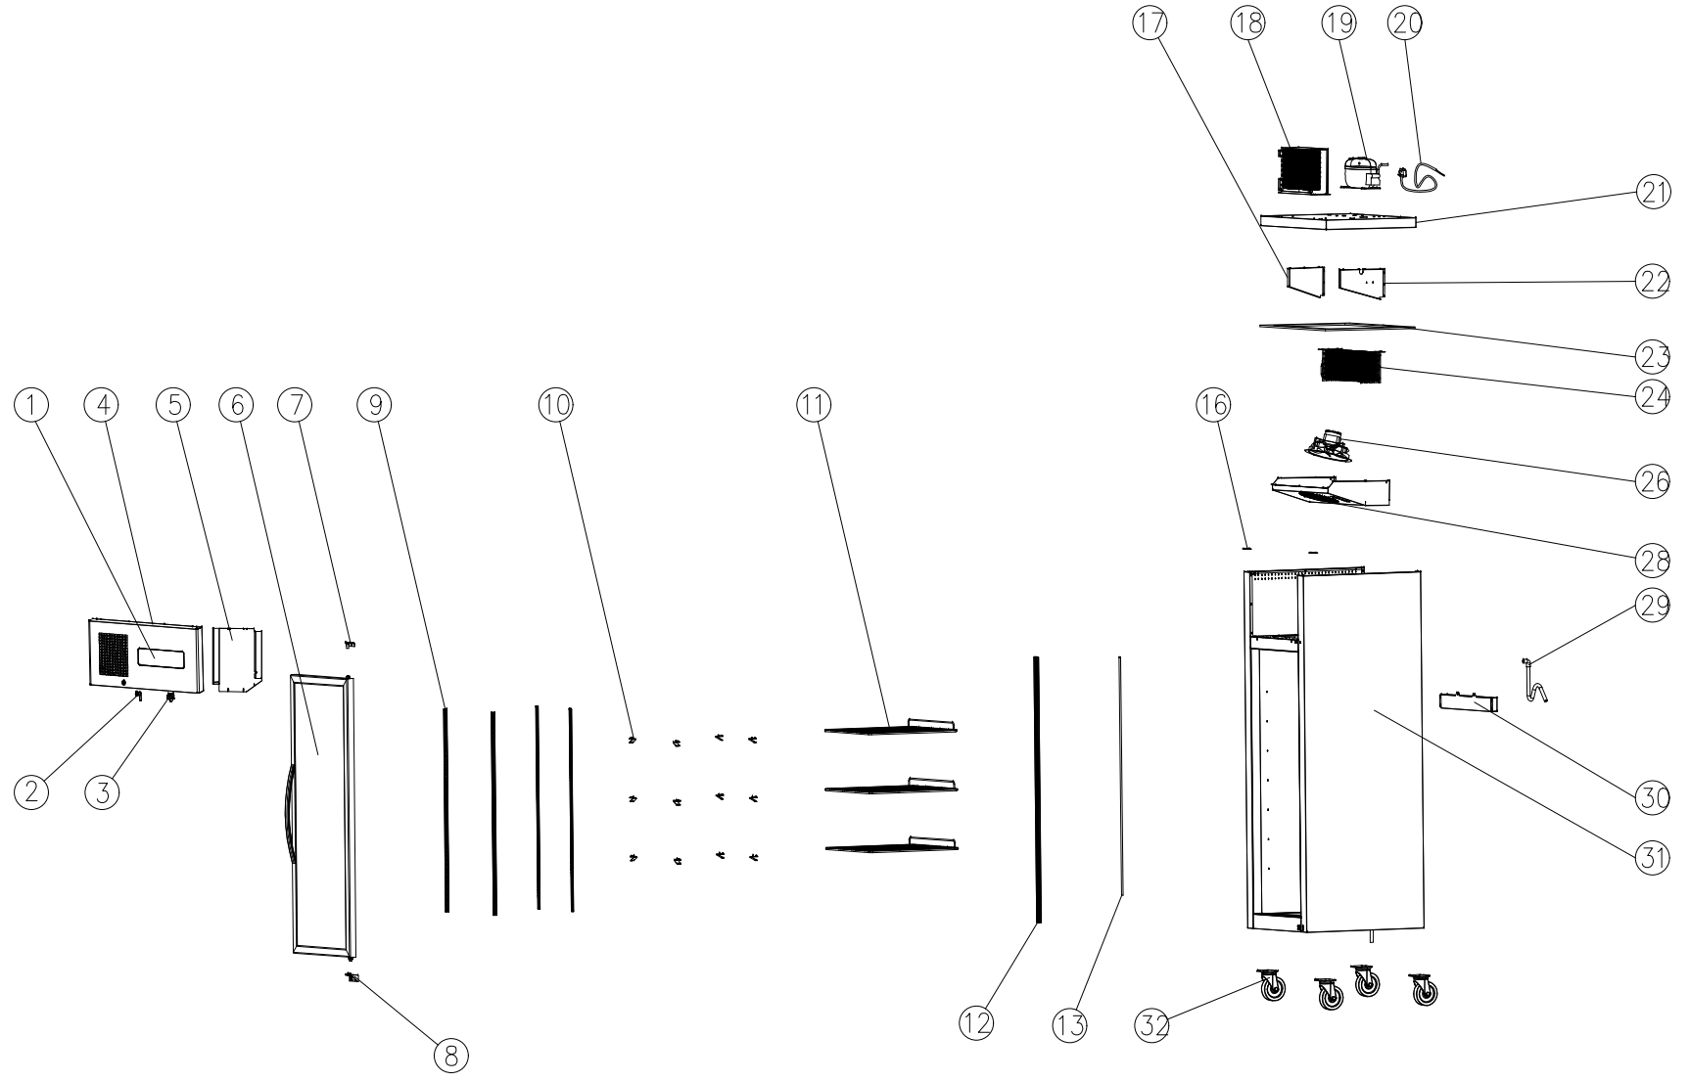
Item |  | FHE Part Code | Description | Qty | Remark
1* |  | SUC-SUF-TCK | Touch Controller Kit | 1
2 |  | SUC/SUF-Key | Key & Lock Assembly | 1
3* |  | SUCG500-FS | Fan Switch | 1
4 |  | SUCG500-TP | Top Panel | 1
5 |  | SUCG500-TCPP | Temperature Control Protection Panel | 1
6* |  | SUCG1000-RD-X | Right Glass Door | 1
7* |  | SUCG1500-TRDH-X | Top Door Hinge | 1
8* |  | SUCG1500-BRDH-X | Bottom Door Hinge | 1
9 |  | SUCG500-KSS | K-type Seal Strip | 4
10 |  | SUF600-20 | Shelf K Clip | 12
11* |  | SUFG500-2 | Wire Shelf 480mm X 530mm | 3
12* |  | SLP850C-9 | LED Light Warm White 1180mm
13 |  | SUCG500-LTS | Light Transmitting Sheet
16* |  | SUCG500-TCH | Top Cover Hinge
17 |  | SUCG500-LEB | Left Evaporator Baffle
18* |  | SUCG500-COND | Condenser

Item |  | FHE Part Code | Description | Qty | Remark
19* |  | EMS6170Z | Compressor | 1
20 |  | SUCG500-PC | Power Cord | 2
21 |  | SUCG500-LCP | Lower Cover Plate | 1
22 |  | SUCG500-REB | Right Evaporator Baffle | 1
23 |  | SUCG500-PIC | PE Insulation Cotton | 1
24* |  | SUF500-35 | Evaporator 5R6K320L | 1
26* |  | SUCG500-EFMA | Evaporator Fan Motor Assembly | 1
28 |  | SUCG500-EFC | Evaporator Fan Cover | 4
29 |  | SUCG500-DP | Drain Pipe | 12
30 |  | SUCG500-EWT | Water Tray For Evaporator | 3
31 |  |  | Cabinet Body | 1
32 |  | SUF1000-NC-X | Normal Castor | 4
 |  | SUF1000-BC-X | Brake Castor
 |  | SUF1000-PH | Pan/Drain Heater
 |  | Drier-1 | DRIER LIQUID LINE DML032S 1/4 SOLDER
 |  | SUCG1000-DG-X | Door Gasket

Item |  | FHE Part Code | Description | Qty | Remark
 |  | SUCG500-CFM | Condenser Fan Motor

*Wearable parts

