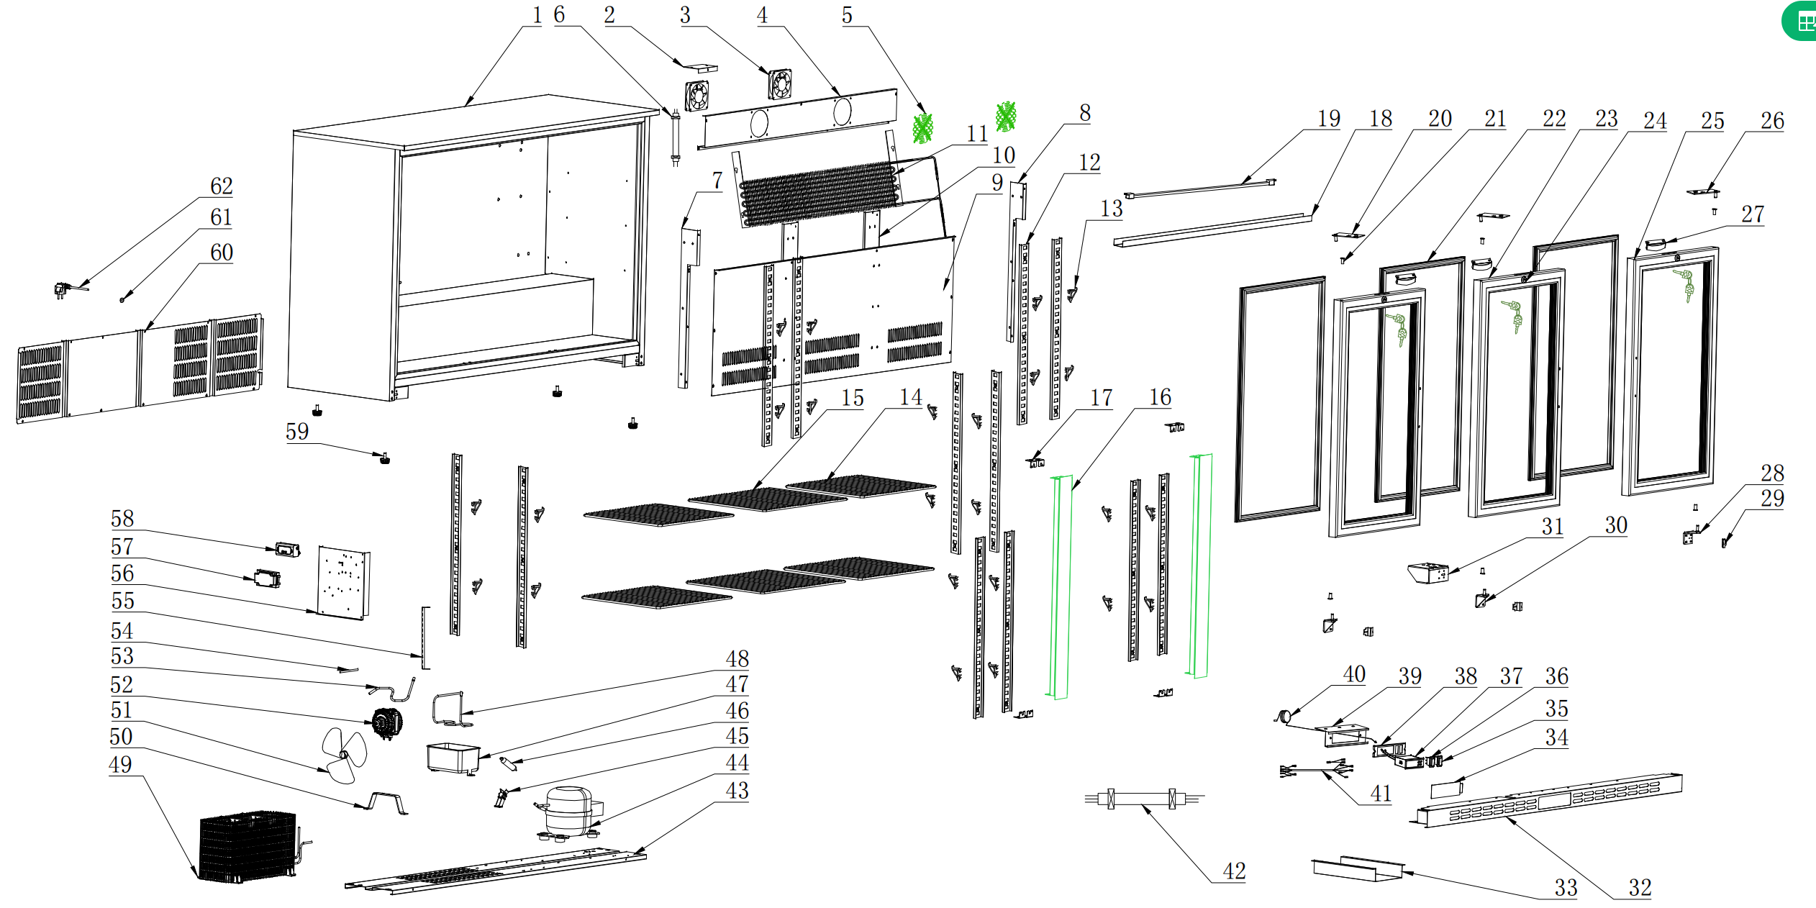
Item |  | FHE Part Code | Description | Qty | Remark
1 |  |  | Cabinet Assembly | 1
2 |  | F.300.004.248HC-005 | Ducting Board Bracket B | 1
3* |  | M.200.002.SDQ-SAD12038B12L-02/2 | Evaporator Fan DC 12V 0.27A SAD12038B12L | 1
4 |  | F.203.001.208HA-001 | Fan Board | 1
5 |  | T.403.005.338FA-001 | Evaporator Fan Cover | 1
6 |  | M.5L1.003.208HA-029 | Dc Motor Connection Cable | 1
7 | Version 1 | F.300.004.208HC-001-B | Support for Air Duct Board（Left） | 1 | Interchangeable
7 | Version 2 | F.300.004.208HC-013-B | Support for Air Duct Board（Left） | 1 | Interchangeable
8 | Version 1 | F.300.004.208HC-002-B | Support for Air Duct Board（Right） | 1 | Interchangeable
8 | Version 2 | F.300.004.208HC-014-B | Support for Air Duct Board（Right） | 1 | Interchangeable
9 | Version 1 | F.300.003.208HC-006 | Ducting Board | 1 | Interchangeable
9 | Version 2 | F.300.003.208HC-017 | Ducting Board | 1 | Interchangeable
10 | Version 1 | F.300.002.208HC-006-B | Support Panel for K-support | 1 | Interchangeable
10 | Version 2 | F.300.002.208HC-014-B | Support Panel for K-support | 1 | Interchangeable
11* | Version 1 | LG-208SC-41 | Evaporator N.15B.002.208HA-003 | 1 | Interchangeable
11* | Version 2 | N.15B.002.208HA-008 | Evaporator | 1 | Interchangeable
12 |  | T.202.001B.208HC-334-02 | Support Panel for K-support | 8
13 |  | LG-1000E-17-New | New Smaller Shelf K Clip T.204.002.1000WBA-007 | 16

Item |  | FHE Part Code | Description | Qty | Remark
14* | Version 1 | P.107.002.208HA-008 | Left/Right Shelf | 4 | Interchangeable
14* | Version 2 | LG330H-43 | Left/Right Shelf 345mm X 400mm P.107.208H-001 | 4 | Interchangeable
15 | Version 1 | C.03.002X.208HC-002A-HZ | Middle Pole Assembly | 1 | Non-Interchangeable
15 | Version 2 | C.03.002X.208HC-011-HZ | Middle Pole Assembly | 1 | Non-Interchangeable
16 | Version 1 | F.103.004.208HA-005 | Support Panel for Middle Pole Assembly | 2 | Interchangeable
16 | Version 2 | F.103.004.208HA-007 | Support Panel for Middle Pole Assembly | 2 | Interchangeable
17 |  | DZ.501.003.208HA-818-03 | Lamp Cover | 1
18* | Version 1 | LG-208HC-Light | Light M.305.004.700-2835-30-01-B-EL | 1 | Interchangeable
18* | Version 2 | M.305.004.700-2835-30-01-B-SM | LED Light | 1 | Interchangeable
19* |  | C.07.208SC-001-H | Sliding Door Channel Assembly | 1
20 |  | DZ.708.010.330SA-002 | Sliding Door Anti-Collision Block | 2
21* |  | DZ.708.001.208SC-710-H | Sliding Door Frame Channel Seal | 2
22 |  | T.402.008.208SB-001-B | Counterweight Block | 2
23* |  | T.207.004.208SC-001 | Sliding Door Guide Wheel | 2
24* |  | DM.706.003.MT-5*10-H | Sealing Wool Pile 5*10 | 4
25* |  | DM.706.003.MT-5*5-H | Sealing Wool Pile 5*5 | 4
26* |  | C.02.005.208SC-01L-H-FB | Glass Door Assembly Left | 1
27 |  | T.205.005 | Nylon Rope | 2

Item |  | FHE Part Code | Description | Qty | Remark
28* |  | C.02.005.208SC-01R-H-FB | Glass Door Assembly Right | 1
29* |  | T.402.001.208SA-001 | Key & Lock | 1
30* |  | E.402.208S-003 | Door Bottom Sliding Wheel | 4
31 |  | F.300.001.208SA-001 | Guide Rail | 2
32 | Version 1 | F.207.001.208SA-006-HZ | Front grill | 1 | Interchangeable
32 | Version 2 | F.207.001.208SA-015-HZ | Front grill | 1 | Interchangeable
33 |  | T.403.010.208HA-011 | Strength metal for ventilation cover | 1
34 |  | DZ.708.008.208HA-007 | Protective Cover | 1
35* |  | M.302.001.208HA-003 | Power switch (Red) | 1
36* |  | LG138H-3 | Light Switch (Green) M.302.001.208HA-004 | 1
37* | Version 1 | LG138H-18 | Digital Thermostat Carel RCBHS1H0E1K | 1 | SN From 20151201001 to 20210730012
37* | Version 2 | M.401.002.ECS-16-01 | Digital Thermostat | 1 | SN From 20210901001
38 |  | DZ.708.008.208HA-005-H | LED Display Controller Cover | 1
39 |  | DZ.708.008.208HA-006-H | Temperature Gauge Board Assembly | 1
40 |  | M.401.002.ECS-16-2500 | Temperature Probe Wire | 1
41 |  | M.5L2.001.360FA-009 | Connect Wire for Compressor | 1
42 |  | M.5L2.003.208HA-059 | Connect Wire for Digital Thermostat | 1
43 |  | F.201.001.208HA-013 | Compressor Supporter | 1

Item |  | FHE Part Code | Description | Qty | Remark
44* | Version 1 | EMT75HLP | Compressor R134a | 1 | SN From 20151201001 to 20210121018
44* | Version 2 | PZ99H1X | Compressor R600a M.10P.PZ99H1X | 1 | SN From 20210301001
45 |  | DZ.708.003.660WA-001 | Water Tray | 1
46 |  | N.300.002.208HA-009 | Venting Tube | 1
47 |  | T.403.003.208HA-003 | Condenser Bracket | 1
48* |  | M.200.001.208HA-009/2 | Condenser Motor | 1
49 |  | T.403.005.660WA-002 | Fan Blade | 1
50 |  | DZ.708.010.1000WBA-004-H | Dry Filter Clip | 1
51 |  | LG-208HC-2 | Dry Filter N.101.228FA-001 | 1
52* |  | N.20C.208HA-007 | Condenser | 1
53 |  | N.300.004.138HC-001 | Evaporator Pipe | 1
54 | Version 1 | N.300.228FA-005 | Process Pipeline | 1 | Interchangeable
54 | Version 2 | N.300.003.208HA-001 | Process Pipeline | 1 | Interchangeable
55 |  | F.202.001.208HA-008 | Electronic Supporting Plate | 1
56 |  | DZ.708.005.660WA-001/2 | Connecting Box | 1
57* |  | M.405.001.HS-EVS-A120150N-A0C-W1 | 12V Power Supply(18W) | 1
58 |  | LG208H-Legs | Adjustable Leg DZ.708.004.208HA-002-H | 4

*Wearable parts
Item |  | FHE Part Code | Description | Qty | Remark
59 | Version 1 | LG-208HC-RP | Rear Panel F.208.001.208HA-006 | 1 | Interchangeable
59 | Version 2 | F.208.001.208HA-013 | Rear Panel | 1 | Interchangeable
60 |  | T.203.001.001 | Cable grommet | 1
61 |  | M.600.E3-075-2200-H | Power Cord 10A 0.75mm² 2200mm Fork Terminal | 1
62 |  | DZ.708.004.BJ9A-001-H | Space feet from wall | 2

