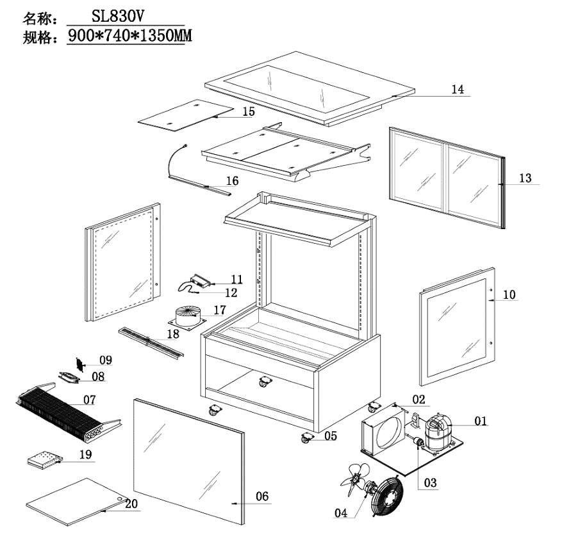
Item |  | FHE Part Code | Description | Qty | Remark
1* |  | SC15MFX | Compressor R134A | 1
2* |  | SL830V-7 | Condenser 3mm X 8mm X 500mm | 1 | Same as SLP840C-8
3* |  | Drier-1 | Filter Drier DML032S | 1
4* |  | SL830V-CM | Condenser Motor 31W | 2
5 | Version 1 | SLP830C-13 | Normal Castor 2 Inch | 4
5 | Version 2 | SLP830C-14 | Brake Castor 2 Inch | 4
6* |  | SL830V-1 | Front Square Glass 828mm X 851mm | 1
7* |  | SL830V-6 | Evaporator 6mm X 4mm X 570mm | 1
8* | Version 1 | FAN-120X120MM | Metal Body Plastic Blade Fan EBM9656/B02 120mm X 120mm X 38mm | 2
8* | Version 2 | FAN-04 | Metal Body Plastic Blade Square Fan 120mm X 120mm X 38mm | 2
9 |  | SL830V-FC | Fan Cover 120mm X 120mm | 2
10* | Left | SL830V-2 | Left Side Glass 720mm X 858mm | 1
10* | Right | SL830V-2A | Right Side Glass 720mm X 858mm | 1
11* | Version 1 | TEMP CONT SF-212 | Temperature Controller SF-212 | 1 | 2019 Version
11* | Version 2 | TC-SF-172E | Temperature Controller SF-172E | 1 | 2024 Version
12 |  | SL830V-PW | Wire of Probe Black/White | 1
13 |  | SL830V-4 | Rear Sliding Door 360mm W X 787mm H | 2
14* |  | SL830V-3 | Top Glass 875mm X 730mm | 1

Item |  | FHE Part Code | Description | Qty | Remark
15* |  | SL830V-14 | Black Glass Shelf 373mm X 350mm | 6
16* | COLD | SG090FA-LED 1 | LED Light Cool White 585mm | 4
16* | WARM | SG090FA-LED | LED Light Warm White 585mm
17* |  | SL830V-CTT | Cylindrical Type Transformer 200W 30V | 1
18 |  | SL830V-SSADP | Stainless Steel Air Duct Plate 720mm X 77mm | 2
19* |  | SG-SL-LT-60W | LED Light Transformer 60W 12V 5A | 1
20 |  | H-SL830-bottom panel | Bottom Panel Set 394mm X 360mm | 2
 |  | SL830V-SSN | Shelf Screw And Nut
 |  | BPT-Side | Black Plastic Trim Left/Right Side 1 pcs
 |  | Plug-Socket-Set | Light Plug and Socket Set
 |  | SC15G-Relay | Relay 117U6005
 |  | SGBP090FA-2XB-MWR | Middle Level Wire Rack 373mm X 350mm
 |  | SL830V-4A | Door Guide/track
 |  | SL830V-8 | Front Panel No Holes
 |  | SL830V-RBP | Rear Bottom Panel
 |  | TBPT-900mm | Top Black Plastic Trim Suit 900mm Long Machine

*Wearable parts

