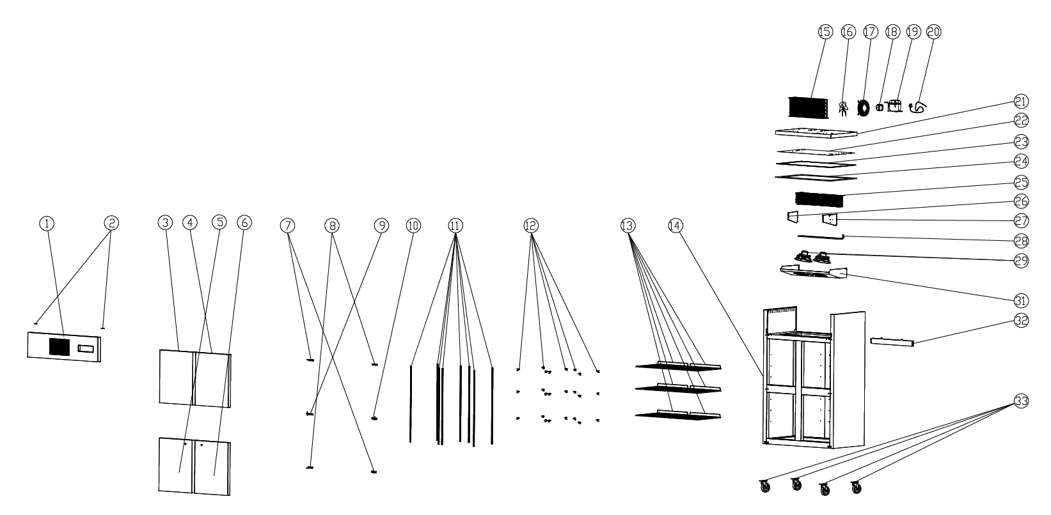
Item |  | FHE Part Code | Description | Qty | Remark
1 |  | SUC1000-TSSP-X | Front Cover Plate Assembly | 1
2 |  | SUF1000-Hinge | Hinge | 2
3 |  | SUC1000-ULD | Upper Left Door | 1
4 |  | SUC1000-URD | Upper Right Door | 1
5 |  | SUC1000-LLD | Lower Left Door | 1
6 |  | SUC1000-LRD | Lower Right Door | 1
7-1* |  | SUC1000-BLDH-X | Left Spring Hinge Base | 1
7-2* |  | SUC1000-TRDH-X | Top Right Door Hinge | 1
8-1* |  | SUC1000-BRDH-X | Right Spring Hinge Base | 1
8-2* |  | SUC1000-TLDH-X | Top Left Door Hinge | 1
9* |  | SUC1000-MLDH-X | Left Middle Hinge Assembly | 1
10* |  | SUC1000-MRDH-X | Right Middle Hinge Assembly | 1
11 |  | SUF1000-KSS | K-type Seal Strip | 8
12 |  | SUF600-20 | K-type Clip | 24
13* |  | SUF10A4.00-01 | Wire Shelf 530mm X 530mm | 6
14 |  |  | Cabinet Body | 1

Item |  | FHE Part Code | Description | Qty | Remark
15* |  | SUF1000-27 | Condenser | 1
16 |  | SUF1000-CFB | Condenser Fan Blade | 1
17 |  | SUF1000-CFG | Condenser Fan Guard | 1
18* |  | SUF1200-39 | Condenser Fan Motor YZF34-45 34/120W | 1
19* |  | NEU2178GK | Compressor R404A | 1
20 |  | SUF1000-PC | Power Cord | 1
21 |  | SUF1000-UCP | Upper Cover Plate | 1
22 |  | SUF1000-LCP | Lower Cover Plate | 1
23 |  | SUF1000-TEF | Top Edge Frame | 1
24 |  | SUF1000-PEIC | PE Insulation Cotton | 1
25* |  | SUF1000-40 | Evaporator 5R6K680L | 1
26 |  | SUF1000-LEB | Left Evaporator Baffle | 1
27 |  | SUF1000-REB | Right Evaporator Baffle | 1
28* |  | SUF1000-41 | Defrost Heating Tube | 1
29 |  | SUF1000-EFMA | Evaporator Fan Motor Assembly | 2
31 |  | SUF1000-EFC | Evaporator Fan Cover | 1

*Wearable parts
Item |  | FHE Part Code | Description | Qty | Remark
32 |  | SUF10A4.00-11 | Water Tray For Evaporator | 1
33-1 |  | SUF1000-BC-X | Brake Castor | 2
33-2 |  | SUF1000-NC-X | Normal Castor | 2
 |  | SUC-SUF-TCK | Touch Controller Kit
 |  | Drier-1 | DRIER LIQUID LINE DML032S 1/4 SOLDER
 |  | T0324 | AV4R Access Valve 1/4MF SCHRADER x 1/4 TAIL
 |  | SUC1000-DG-X | Door Gasket 690mm by 540mm
 |  | SUF1000-PH | Pan/Drain Heater

