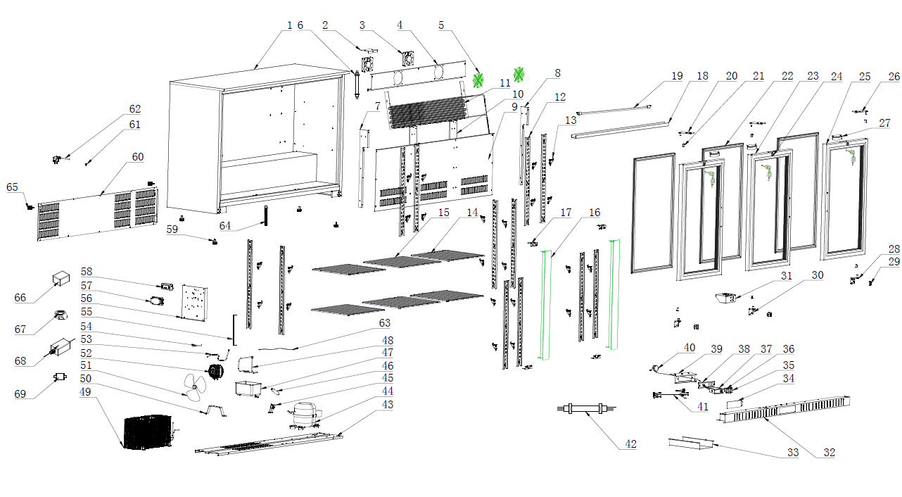
Item |  | FHE Part Code | Description | Qty | Remark
1 |  |  | Cabinet Assembly | 1
2 |  | F.300.004.248HC-005 | Ducting Board Bracket B | 1
3* |  | M.200.002.SDQ-SAD12038B12L-02/2 | Evaporator Fan DC 12V 0.27A SAD12038B12L | 2
4 |  | F.203.001.330HA-001 | Fan Board | 1
5 |  | T.403.005.338FA-001 | Evaporator Fan Cover | 2
6 |  | M.5L1.003.330HA-029 | Dc Motor Connection Cable | 1
7 |  | F.300.004.208HC-013-B | Support for Air Duct Board（Left） | 1
8 |  | F.300.004.208HC-014-B | Support for Air Duct Board（Right） | 1
9 |  | F.300.003.330HC-017 | Ducting Board | 1
10 |  | F.300.002.208HC-014-B | Support Panel for K-support | 2
11* |  | N.15B.002.330HA-008 | Evaporator | 1
12 |  | T.202.001B.208HC-334-02 | Support Panel for K-support | 12
13 |  | LG-1000E-17-New | New Smaller Shelf K Clip T.204.002.1000WBA-007 | 24
14* |  | LG330H-43 | Left/Right Shelf 345mm X 400mm P.107.208H-001 | 4
15 |  | LG330H-50 | Middle Shelf 345mm X 445mm P.107.330H-001 | 2
16 |  | C.03.002X.208HC-015-HZ | Middle Pole Assembly | 2
17 |  | F.103.004.208HA-007 | Support Panel for Middle Pole Assembly | 4
18 |  | DZ.501.003.330HA-1268-03 | Lamp Cover | 1

Item |  | FHE Part Code | Description | Qty | Remark
19* |  | M.305.004.1100-2835-30-01-B-SM | LED Light | 1
20* |  | LG-208HC-46-TLH | Top Door Hinge(left) T.402.003.208HA-032L-HZ | 2
21 |  | DM.706.005.228FA-001-H | Door Shaft Sleeve | 6
22* |  | DM.60R.330HC-005-H | Door Gasket | 3
23* |  | C.02.006.330HC-030BL-H-AA | Left Door Assembly | 2
24* |  | LG-208HC-LK | Lock & key T.402.001.208HA-001 | 3
25* |  | C.02.006.330HC-030BR-H-AA-092 | Right Door Assembly | 1
26* |  | LG138H-41 | Top Right Door Hinge T.402.003.208HA-032R-HZ | 1
27* |  | LG-330HC-DH | Door Handle (Metal) T.402.002.208HA-001-H | 3
28* |  | LG138H-41A | Door Hinge Bottom Right Hand T.402.003.208HA-031-HD | 1
29 |  | T.402.007.330HA-002 | Iron Support Fastener | 3
30* |  | LG-208HC-46-BLH | Door Hinge Bottom Left Hand T.402.003.208HA-030-HD | 2
31 |  | T.403.010.330HA-006 | The Nut Plate for the Door Hinge | 1
32 |  | F.207.001.330HA-041-HZ | Front Grill | 1
33 |  | T.403.010.208HA-011 | Strength metal for ventilation cover | 1
34 |  | DZ.708.008.208HA-007 | Protective Cover | 1
35* |  | M.302.001.208HA-003 | Power switch (Red) | 1
36* |  | LG138H-3 | Light Switch (Green) M.302.001.208HA-004 | 1

Item |  | FHE Part Code | Description | Qty | Remark
37* |  | ECS-16 Temp Controller | Digital Thermostat | 1
38 |  | DZ.708.008.208HA-005-H | LED Display Controller Cover | 1
39 |  | DZ.708.008.208HA-006-H | Temperature Gauge Board Assembly | 1
40 |  | M.401.002.ECS-16-2500 | Temperature Probe Wire | 1
41 |  | M.5L2.001.360FA-009 | Connect Wire for Compressor | 1
42 |  | M.5L2.003.330HA-059 | Connect Wire for Digital Thermostat | 1
43 |  | F.201.001.330HA-013 | Compressor Supporter | 1
44* |  | PZ99H1X | Compressor R600a M.10P.PZ99H1X | 1
45 |  | DZ.708.010.1000WBA-004-H | Dry Filter Clip | 1
46 |  | LG-208HC-2 | Dry Filter N.101.228FA-001 | 1
47 |  | DZ.708.003.660WA-001 | Water Tray | 1
48 |  | N.300.002.208HA-009 | Venting Tube | 1
49 |  | LG-330HC-Cond | Condenser N.20C.330HA-007 | 1
50 |  | T.403.003.208HA-003 | Condenser Bracket | 1
51 |  | T.403.005.660WA-002 | Fan Blade | 1
52* |  | M.200.001.208HA-009/2 | Condenser Motor | 1
53 |  | N.300.004.138HC-001 | Evaporator Pipe | 1
54 |  | N.300.003.208HA-001 | Process Pipeline | 1

*Wearable parts
Item |  | FHE Part Code | Description | Qty | Remark
55 |  | T.403.006.330HA-001 | Plate Support Frame | 1
56 | Version 1 | F.202.001.208HA-008 | Electronic Supporting Plate | 1
56 | Version 2 | F.202.001.208HA-013 | Electronic Supporting Plate | 1
57 |  | DZ.708.005.660WA-001/2 | Connecting Box | 1
58* |  | M.405.001.HS-EVS-A120150N-A0C-W1 | 12V Power Supply(18W) | 1
59 |  | LG208H-Legs | Adjustable Leg DZ.708.004.208HA-002-H | 4
60 |  | F.208.001.330HA-013 | Rear Panel | 1
61 |  | T.203.001.001 | Cable Grommet | 1
62 |  | M.600.E3-075-2200-H-W12 | Power Cord 10A 0.75mm² 2200mm L Pin Terminal | 1
63 |  | M.5L2.228FA-001 | Compressor Grounding Wire | 1
64 |  | T.211.003.208HA-003-H | Inner Cabinet Drain Pipe | 1
65 |  | DZ.708.004.BJ9A-001-H | Space feet from wall | 2
66* |  | M.408.248HC-HT125-10-L8-B3 | Filter | 1
67 |  | DZ.708.010.660WA-004 | Power Cord Clip | 1
68* |  | M.405.001.D150WA-002 | Electrical Heating Door Power Supply | 1
69 |  | T.403.010.D150WA-001 | Electrical Door Heating Power Supply Fixing Bracket | 1

