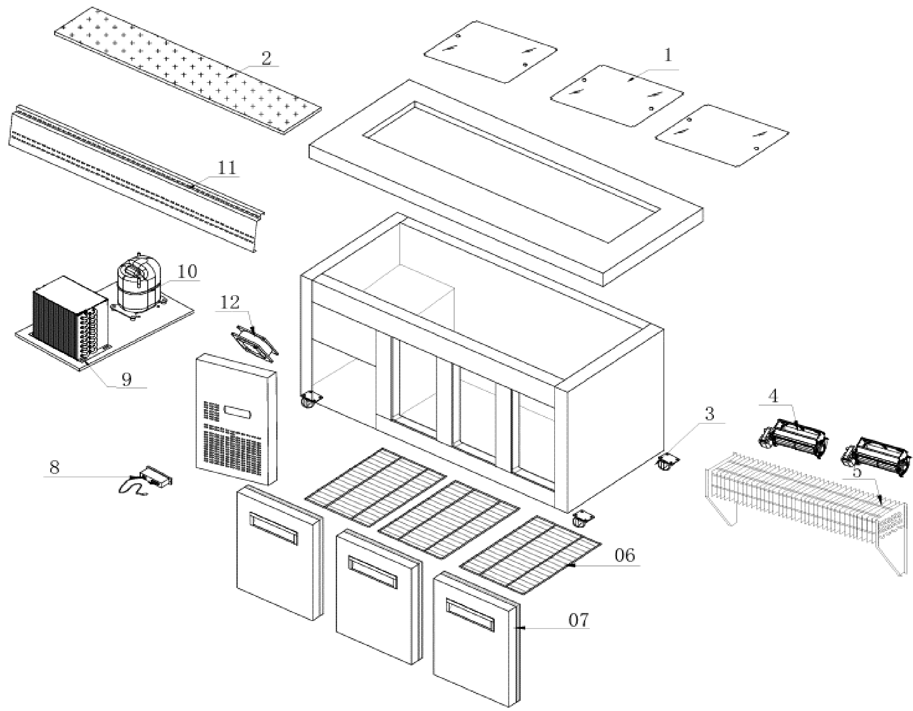
Item |  | FHE Part Code | Description | Qty | Remark
1 |  | PG210FA-XB-PSDS | Perspex Sliding Doors Set  420mm X 557mm 3 Pcs + 420mm X 586mm 2 Pcs | 1
2 |  | PG210FA-XG-CB | Chopping Board 2140mm X 220mm | 1
3 |  | PG150FE-11 | Normal Castor 3 Inch | 2
3 |  | PG150FE-11A | Brake Castor 3 Inch | 2
4 | Version 1 | FAN-04 | Metal Body Plastic Blade Square Fan 120mm X 120mm X 38mm | 4 | SN From 384111 to 384112
4 | Version 2 | PG150FA-XB-ECFF | Evaporator Cross Flow Fan Weiguang YGF60-240 | 2 | SN From 385784
5 |  | PG210FA-XG-Evap | Evaporator 5 X 4 X 1200 | 1
6 | Side | PG210FA-XG-SS | Side Shelf 520mm X 500mm | 2
6 | Middle | PG210FA-XG-MS | Middle Shelf 552mm X 500mm | 1
7 |  | PG210FA-XG-DS | Door Seal 550mm X 645mm | 2
8 |  | TEMP CONT SF-102 | Temp Controller SF102 | 1
9 |  | PG180FA-XB-Cond | Condenser 3 X 11 X 280 | 1
10 |  | SF15MFX | Compressor | 1
11 |  |  | Air Duct Panel 2017mm X 200mm | 1
12 |  | FAN-24 | Fan SJ1225HA2 120mm X 120mm X 25mm 220V-240V AC 0.1A | 1

Item |  | FHE Part Code | Description | Qty | Remark
 |  | PG150FA-XG-CBFB | Chopping Board Fixing Bracket Set
 |  | PG180FE-XG-PD | Pan Divider 535mm X 40mm
 |  | PG210-PERSPEX COVER | Perspex Cover Set (5 PCS) 2 pcs of 586mm X 420mm and 3 pcs 558mm X 420mm

