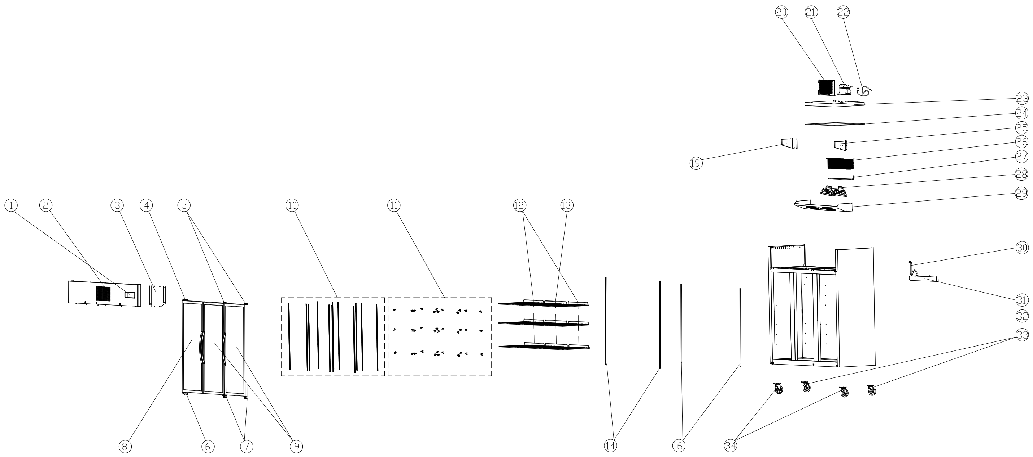
Item |  | FHE Part Code | Description | Qty | Remark
1* |  | SUFG1500-TCK | Touch Controller Kit | 1
2 |  | SUFG1500-TSSP-X | Top Stainless Steel Panel XY Version | 1
3 |  | SUFG1500-TCPP | Temperature Control Protection Panel | 1
4* |  | SUCG1500-TLDH-X | Top Left Door Hinge | 1
5* |  | SUCG1500-TRDH-X | Top Right Door Hinge | 2
6* |  | SUCG1500-BLDH-X | Bottom Left Door Hinge | 1
7* |  | SUCG1500-BRDH-X | Bottom Right Door Hinge | 2
8* |  | SUFG1000-1 | L/H Glass Door 1445mm H X 595mm W | 1
9* |  | SUFG1000-21 | R/H Glass Door | 2
10 |  | SUFG1500-KSS | K-type Seal Strip | 12
11 |  | SUF600-20 | Shelf K Clip | 36
12* |  | SUFG1000-2 | Wire Shelf 530mm X 530mm | 6
13* |  | SUFG1500-20 | Middle Shelf 585mm X 530mm | 3
14* |  | SUFG1500-LSB | Lamp Shade Base | 2
16 |  | SUFG1500-LTS | Light Transmitting Sheet | 2
19 |  | SUFG1500-LEB | Left Evaporator Baffle | 1

Item |  | FHE Part Code | Description | Qty | Remark
20* |  | SUFG1500-Condenser | Condenser | 1
21* |  | NT2212GK | Compressor R404A | 1
22 |  | SUFG1500-PC | Power Cord | 1
23 |  | SUFG1500-LCP | Lower Cover Plate | 1
24 |  | SUFG1500-PEIC | PE Insulation Cotton | 1
25 |  | SUFG1500-REB | Right Evaporator Baffle | 1
26* |  | SUFG1500-Evap | Evaporator | 1
27* |  | SUF1000-41 | Defrost Heating Tube
28* |  | SUFG1500-EFMA | Evaporator Fan Motor Assembly | 1
29 |  | SUFG1500-EFC | Evaporator Fan Cover | 1
30* |  | SUFG1500-DP | Drain Pipe | 1
31 |  | SUFG1500-EWT | Water Tray For Evaporator | 1
32 |  |  | Cabinet Body | 1
33 |  | SUF1000-NC-X | Normal Castor | 2
34 |  | SUF1000-BC-X | Brake Castor | 2
 |  | Drier-1 | DRIER LIQUID LINE DML032S 1/4 SOLDER

*Wearable parts
Item |  | FHE Part Code | Description | Qty | Remark
 |  | SUFG1500-CFM-X | Condenser Fan Motor LF300-T23/4 23W 0.25A 1300r/min 1.5μF/450VAC
 |  | SUFG500-Seal | Door Seal 570mm x 1420mm
 |  | SUF1000-PH | Pan/Drain Heater
 |  | SUFG1500-Contactor | Contactor
 |  | SUFG1500-DE | Drain Elbow

