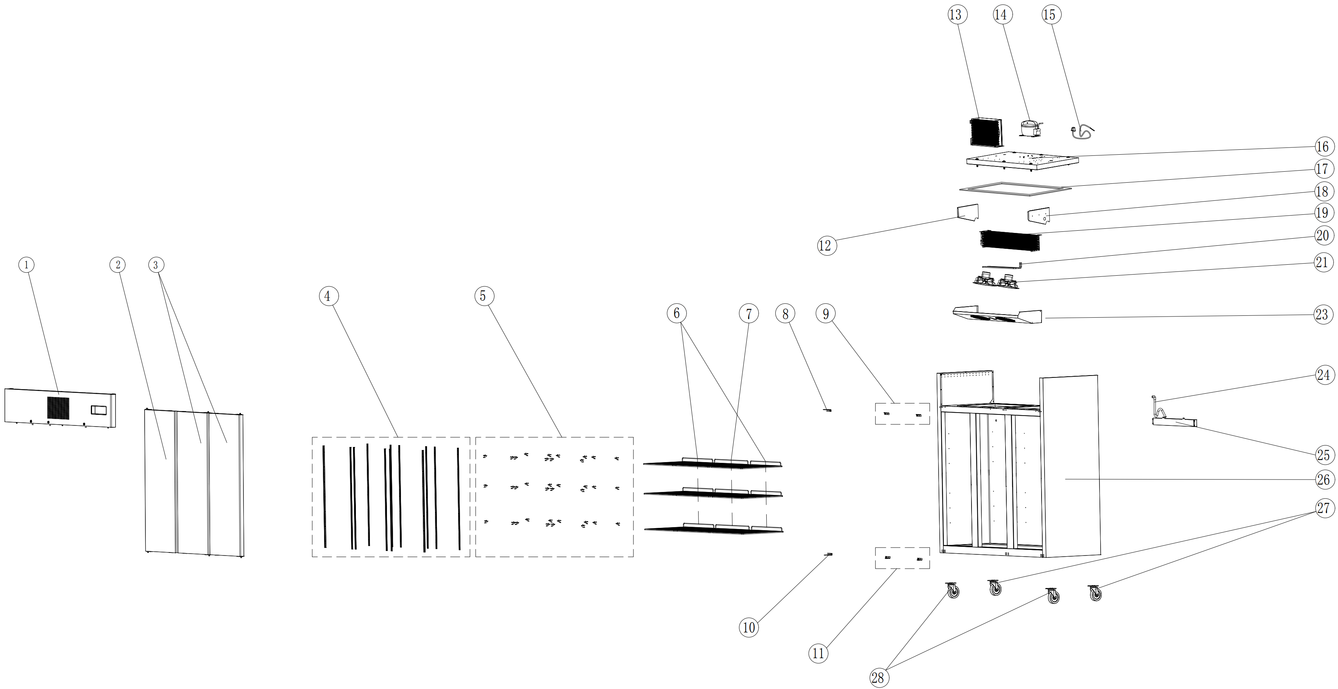
Item |  | FHE Part Code | Description | Qty | Remark
1 |  | SUF1500-TSSP-X | Top Stainless Steel Panel XY Version | 1
2 |  | SUF1500-LD-X | Left Door Assembly | 1
3 |  | SUF1500-RD-X | Right Door Assembly | 2
4 |  | SUF1500-KSS | K-type Seal Strip | 12
5 |  | SUF600-20 | K-type Clip | 36
6* |  | SUF10A4.00-01 | Wire Shelf 530mm X 530mm | 6
7* |  | SUF1500-WS | Wire Shelf 615mm X 530mm | 3
8* |  | SUC1000-TLDH-X | Top Left Door Hinge | 1
9* |  | SUC1000-TRDH-X | Top Right Door Hinge | 2
10* |  | SUC1000-BLDH-X | Bottom Left Door Hinge | 1
11* |  | SUC1000-BRDH-X | Bottom Right Door Hinge | 2
12 |  | SUF1500-LEB | Left Evaporator Baffle | 1
13* |  | SUF1500-Condenser | Condenser | 1
14* |  | NT2192GK | Compressor | 1
15 |  | SUF1500-PC | Power Cord | 1
16 |  | SUF1500-LCP | Lower Cover Plate | 1

Item |  | FHE Part Code | Description | Qty | Remark
17 |  | SUF1500-PEIC | PE Insulation Cotton | 1
18 |  | SUF1500-REB | Right Evaporator Baffle | 1
19* |  | SUC1500-Evap-X | Evaporator | 1
20* |  | SUF1000-41 | Defrost Heating Tube | 1
21* |  | GG120FA-X-2 | Evaporator Fan Motor 70W | 2
23 |  | SUF1500-EFC | Evaporator Fan Cover | 1
24 |  | SUF1500-DP | Drain Pile | 1
25 |  | SUF10A4.00-11 | Water Tray For Evaporator | 1
26 |  |  | Cabinet Body | 1
27 |  | SUF1000-NC-X | Normal Castor | 2
28 |  | SUF1000-BC-X | Brake Castor | 2
 |  | SUF1500-DG-X | Door Gasket
 |  | Drier-1 | DRIER LIQUID LINE DML032S 1/4 SOLDER
 |  | SUC-SUF-TCK | Touch Controller Kit for all SLIS machines
 |  | SUF1000-PH | Pan/Drain Heater
 |  | SUF1500-CFM | Condenser Fan Cover

*Wearable parts

