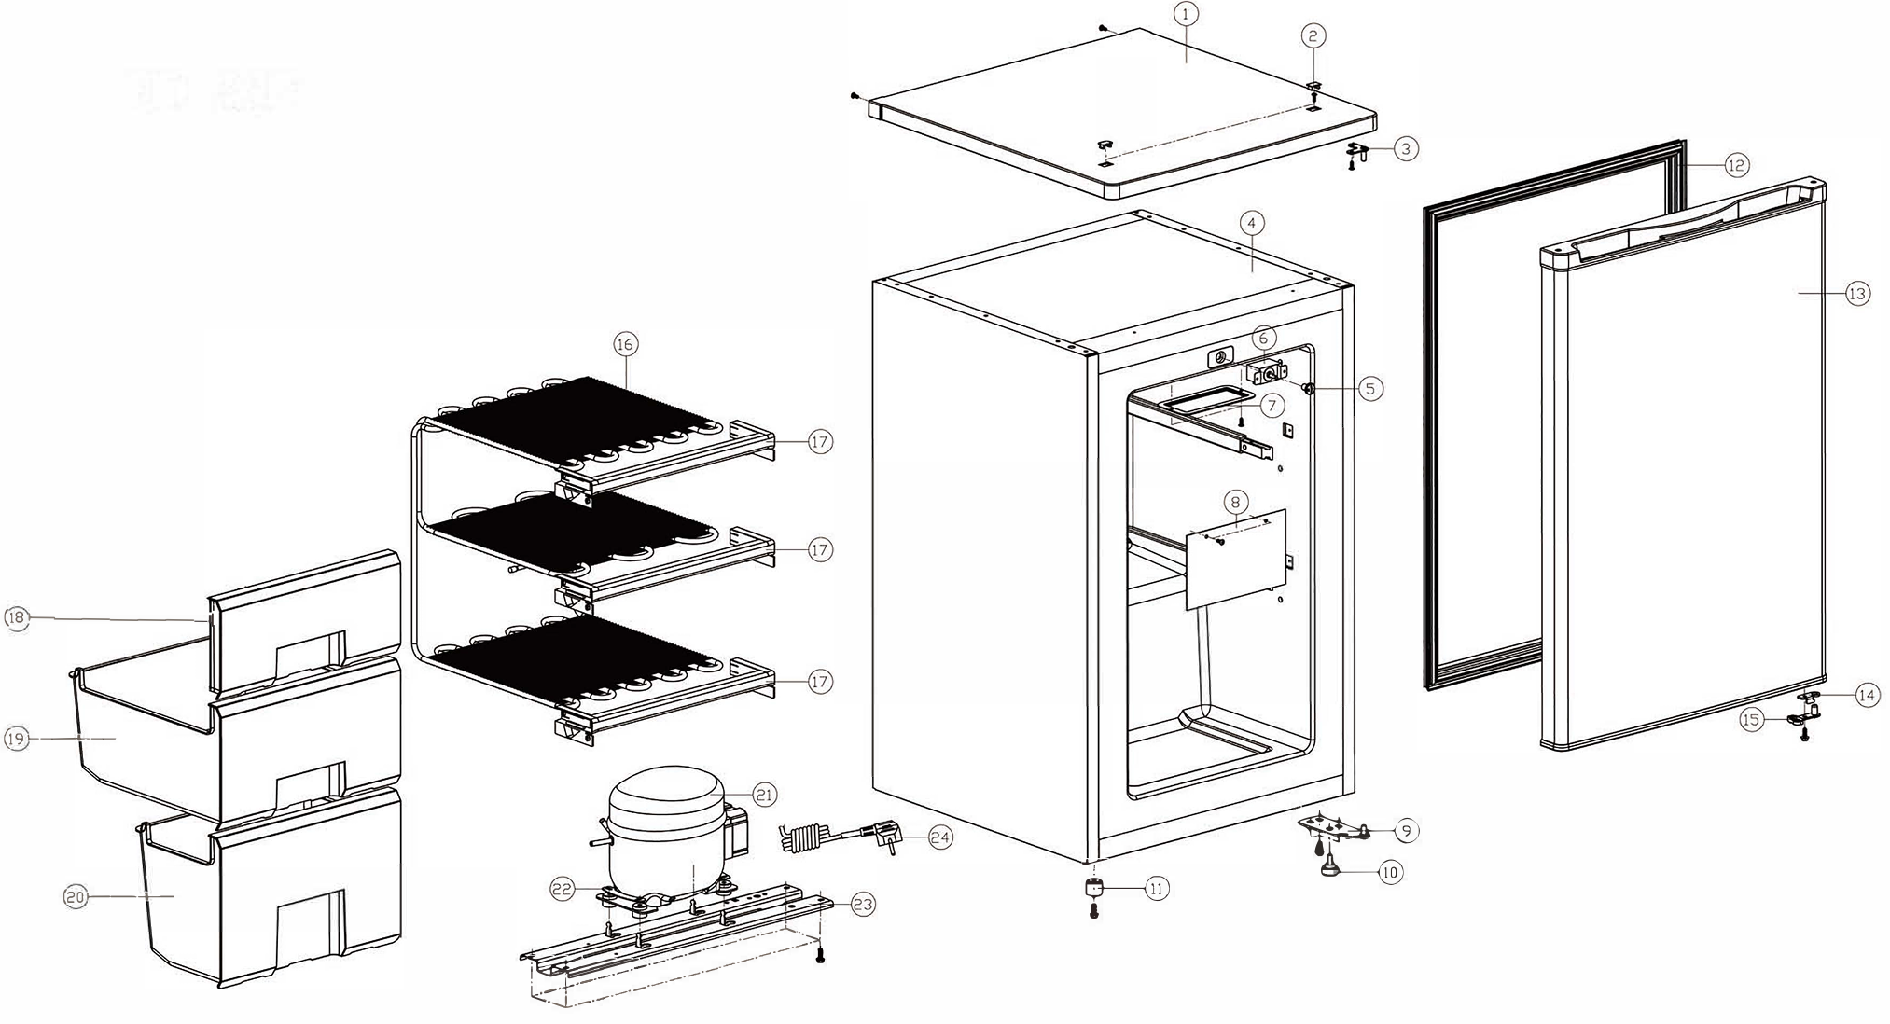
Item |  | FHE Part Code | Description | Qty | Remark
1 |  | DC-80F-TL | Top Lid 1.02.00.2001291 | 1
2 |  | DC-80F-TLC | Top Lid Clip 1.02.00.6000392 | 1
3* |  | DC-80F-UH | Upper Hinge 1.06.00.0000348 | 1
4 |  |  | Body | 1
5 |  | 1.02.00.0001080 | Thermostat Knob | 1
6* |  | DC-80F-Thermostat | Thermostat 250V~ 6(4)A 2E5 T60 WKT34-EX 1.63.00.0000117 | 1
7 |  | 1.02.00.0000928 | Thermostat Cover | 1
8 |  | 1.02.00.0000451 | Evaporator Cover | 1
9 |  | DC-80F-BH | Bottom Hinge 1.06.00.0000424 | 1
10 |  | 1.02.00.0001002 | Adjustable Foot | 1
11 |  | DC-122Q-Foot | Foot 1.02.00.0000264 Also Suit DC-80F | 1
12* |  | DC-80F-DG | Door Gasket 1.21.00.0000116 | 1
13 |  | DC-80F-Door | Door 1.51.00.0001359 | 1
14 |  | 1.02.00.0000349 | Door Stopper | 1
15 |  | 1.02.00.0000348 | Door Lock Catch | 1
16* |  | 1.65.00.0000200 | Freezer Evaporator Assembly | 1
17 |  | 1.02.00.0000223 | Evaporator Retaining Strip | 3
18 |  | DC-80F-Flap | Flap 1.02.00.0002984 | 1

Item |  | FHE Part Code | Description | Qty | Remark
19 |  | DC-80F-MD | Middle Plastic Drawer 1.02.00.1001848 | 1
20 |  | DC-80F-LD | Lower Plastic Drawer 1.02.00.3000875 Suit DC-80F | 1
21* |  | DC-80F-Compressor | Compressor 1.05.011.0164 QD52VY R600a | 1
22 |  | 1.06.00.0000071 | Compressor Mounting Bracket | 2
23 |  | 1.06.00.0000160 | Compressor Base Plate | 1
24 |  | 1.19.00.0000744 | Power Cord H05VV-F | 1
* |  | 1.06.00.0000781 | Handle

