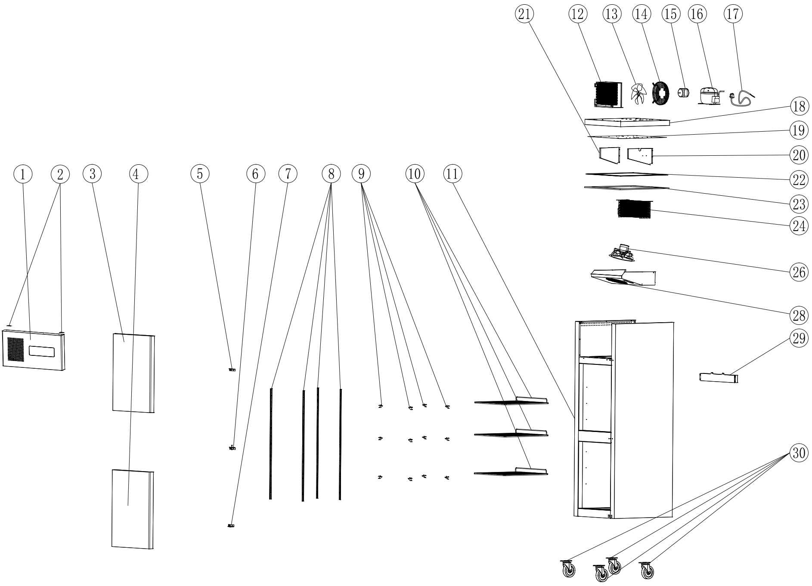
Item |  | FHE Part Code | Description | Qty | Remark
1 |  | SUC500-FCPA | Front Cover Plate Assembly | 1
2 |  | SUC500-Hinge | Hinge | 2
3 |  | SUF10A4.03-00 | Right Upper Door | 1
4 |  | SUF10A4.04-00 | Right Lower Door | 1
5* |  | SUC1000-TRDH-X | Top Right Door Hinge | 1
6* |  | SUC1000-MRDH-X | Middle Right Door Hinge | 1
7* |  | SUC1000-BRDH-X | Bottom Right Door Hinge | 1
8 |  | SCF500-KSS | K-type Seal Strip | 4
9 |  | SUF600-20 | Shelf K Clip | 12
10* |  | SUF5A2.00-01 | Wire Shelf 480mm X 530mm | 3
11 |  |  | Cabinet Body | 1
12* |  | SUF500-23 | Condenser 3R10K320L | 1
13 |  | SUF500-CFB | Condenser Fan Blade | 1
14 |  | SUF500-CFG | Condenser Fan Guard | 1
15* |  | FAN-22 | Condenser Fan Motor Square EBM Style 25W Universal RF515A | 1
16* |  | NE6170Z | Embraco compressor NEK6170Z 1/4HP R134A | 1 | If not stock, please use EMS6170Z

Item |  | FHE Part Code | Description | Qty | Remark
17 |  | SUF500-PC | Power Cord | 1
18 |  | SUF500-UCP | Upper Cover Plate | 1
19 |  | SUF500-LCP | Lower Cover Plate | 1
20 |  | SUF500-REB | Right Evaporator Baffle | 1
21 |  | SUF500-LEB | Left Evaporator Baffle | 1
22 |  | SUF500-TEF | Top Edge Frame | 1
23 |  | SUF500-PEIC | PE Insulation Cotton | 1
24* |  | SUF500-35 | Evaporator 5R6K320L | 1
26* |  | SUF500-EFMA | Evaporator Fan Motor Assembly | 1
28 |  | SUF500-EFC | Evaporator Fan Cover | 1
29 |  | SUF500-EWT | Water Tray For Evaporator | 1
30-1 |  | SUF1000-BC-X | Brake Castor | 2
30-2 |  | SUF1000-NC-X | Normal Castor | 2
 |  | SUF1000-PH | Pan/Drain Heater
 |  | Drier-1 | DRIER LIQUID LINE DML032S 1/4 SOLDER
 |  | SUC-SUF-TCK | Touch Controller Kit

*Wearable parts
Item |  | FHE Part Code | Description | Qty | Remark
 |  | SUC/SUF-Key | Key & Lock Assembly
 |  | SUC1000-DG-X | Door Gasket 690mm by 540mm

