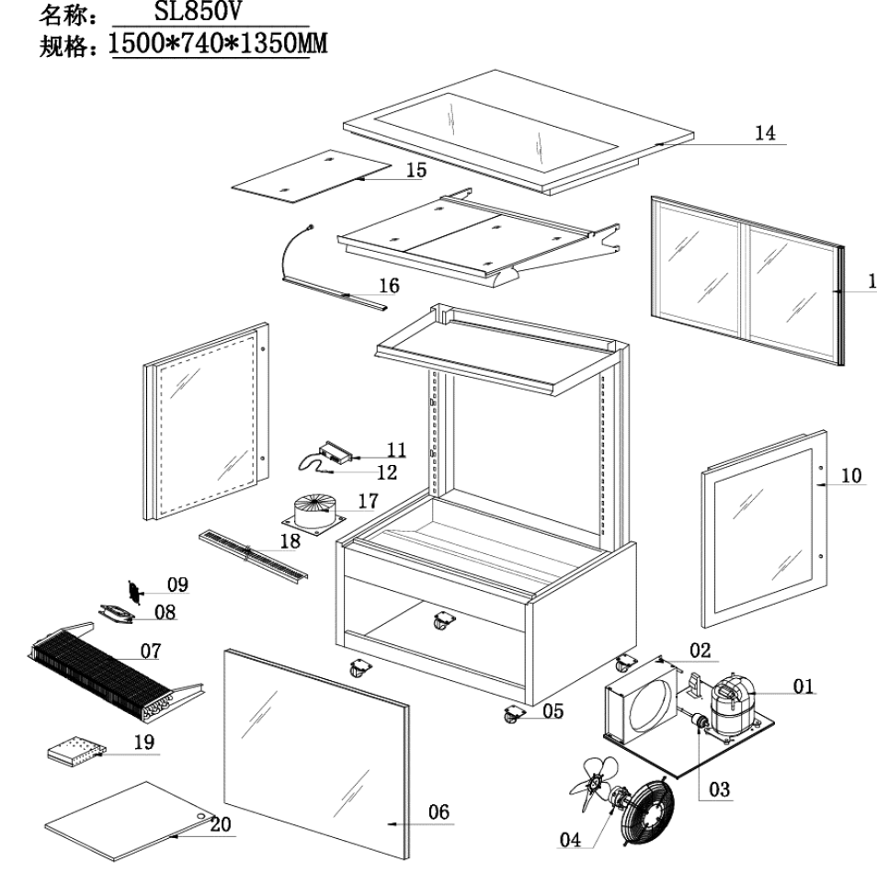
Item |  | FHE Part Code | Description | Qty | Remark
1* |  | SC21CL | Compressor R404a | 1
2* |  | SL880V-7 | Condenser 4mm X 8mm X 500mm | 1
3* |  | Drier-1 | Filter Drier DML032S | 1
4* |  | SL830V-CM | Condenser Motor 31W | 2
5 | Version 1 | SLP830C-13 | Normal Castor 2 Inch | 4
5 | Version 2 | SLP830C-14 | Brake Castor 2 Inch | 4
6* |  | SL880V-1 | Front Square Glass 2328mm X 851mm | 1
7* |  | SL880V-6 | Evaporator 6mm X 4mm X 2070mm | 1
8* | Version 1 | FAN-120X120MM | Metal Body Plastic Blade Fan EBM9656/B02 120mm X 120mm X 38mm | 6
8* | Version 2 | FAN-04 | Metal Body Plastic Blade Square Fan 120mm X 120mm X 38mm | 6
9 |  | SL830V-FC | Fan Cover 120mm X 120mm | 6
10* | Left | SL830V-2 | Left Side Glass 720mm X 858mm | 1
10* | Right | SL830V-2A | Right Side Glass 720mm X 858mm | 1
11* | Version 1 | TEMP CONT SF-212 | Temperature Controller SF-212 | 1 | 2019 Version
11* | Version 2 | TC-SF-172E | Temperature Controller SF-172E | 1 | 2024 Version
12 |  | SL830V-PW | Wire of Probe Black/White | 1
13 |  | SL880V-4 | Rear Sliding Door 551mm W X 788mm H | 4
14* |  | SL880V-3 | Top Glass 2375mm X 730mm | 1

Item |  | FHE Part Code | Description | Qty | Remark
15* |  | SL880V-14 | Black Glass Shelf 749mm X 350mm | 9
16-1* |  | SG120FA-LED A | LED Light Cool White 876mm | 4
16-2* |  | SG150FA-LED A | LED Light Cool White 1180mm | 4
17* |  | SL880V-CTT | Cylindrical Type Transformer 400W 72V | 1
18 |  | SL880V-SSADP | Stainless Steel Air Duct Plate 2220mm X 77mm | 2
19* |  | SL880V-LLT | LED Light Transformer 150W | 1
20 |  | SL880V-BP | Bottom Panel Set 394mm X 740mm | 2
 |  | GG/SG-11 | Glass Flat Screw and Gasket
 |  | Plug-Socket-Set | Light Plug and Socket Set
 |  | SG090FA-2XB-30 | Heating Wire Transformer EEIO-C150VA/19171 0-30-36V
 |  | SL830V-SSN | Shelf Screw And Nut
 |  | SLP880C-11-A | Rear Air Vent Grid 945x283
 |  | SL880V-FP | Front Panel

*Wearable parts

