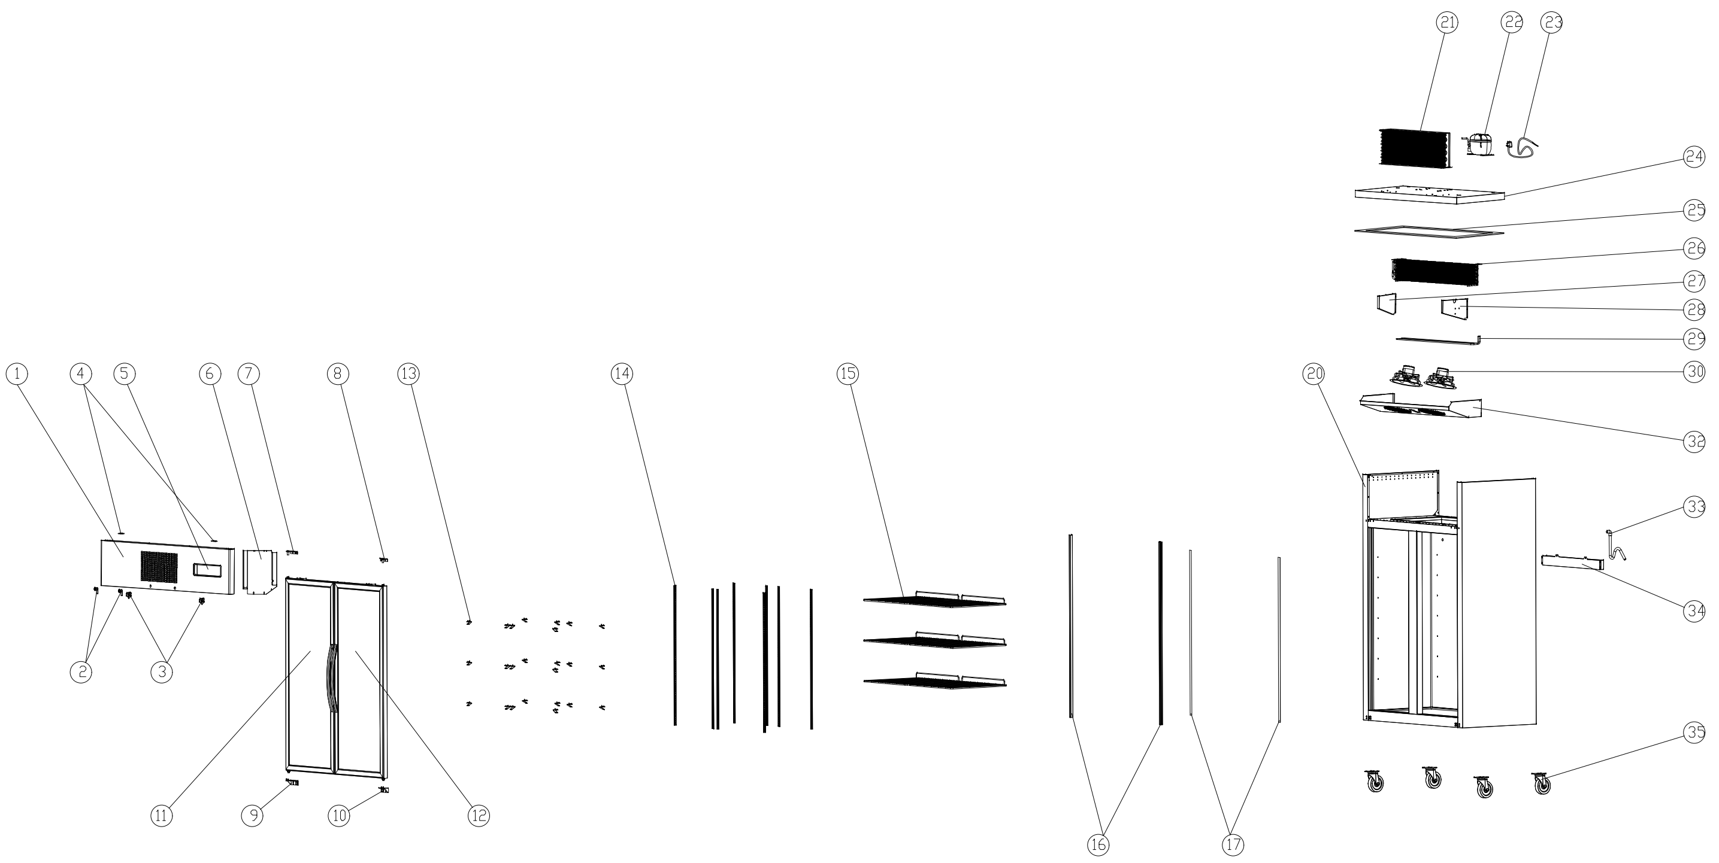
Item |  | FHE Part Code | Description | Qty | Remark
1 |  | SUFG1000-TSSP-X | Top Stainless Steel Panel XY Version | 1
2 |  | SUC/SUF-Key | Key & Lock Assembly | 2
3* |  | SUFG1000-FS | Fan Switch | 2
4 |  | SUFG1000-TCH | Top Cover Hinge | 2
5 |  | SUFG1000-TCPP | Temperature Control Protection Panel | 1
6* |  | SUC-SUF-TCK | Touch Controller Kit | 1
7* |  | SUCG1500-TLDH-X | Top Left Door Hinge | 1
8* |  | SUCG1500-TRDH-X | Top Right Door Hinge | 1
9* |  | SUCG1500-BLDH-X | Bottom Left Door Hinge | 1
10* |  | SUCG1500-BRDH-X | Bottom Right Door Hinge | 1
11* |  | SUFG1000-LD-X | Left Glass Door | 1
12* |  | SUFG1000-RD-X | Right Glass Door | 1
13 |  | SUF600-20 | Shelf K Clip | 24
14 |  | SUCG1000-KSS | K-type Seal Strip | 8
15* |  | SUFG1000-2 | Wire Shelf 530mm X 530mm | 6
16* |  | SUFG1000-20 | LED Light Strip | 2

Item |  | FHE Part Code | Description | Qty | Remark
17 |  | SUFG1000-Light cover | Light Cover L=1374MM | 2
20 |  |  | Cabinet Body | 1
21* |  | SUFG1000-Condenser | Condenser | 1
22* | Version1 | NT2192GK | Compressor R404a | 1
22* | Version2 | SC21CL | Compressor R404a
23 |  | SUFG1000-PC | Power Cord | 1
24 |  | SUFG1000-LCP | Lower Cover Plate | 1
25 |  | SUFG1000-PEIC | PE Insulation Cotton | 1
26* |  | SUF1000-40 | Evaporator 5R6K680L | 1
27 |  | SUFG1000-LEB | Left Evaporator Baffle | 1
28 |  | SUFG1000-REB | Right Evaporator Baffle | 1
29 |  | SUF1000-41 | Defrost Heating Tube | 1
30* |  | SUFG1000-EFMA | Evaporator Fan Motor Assembly | 2
32 |  | SUFG1000-EFC | Evaporator Fan Cover | 1
33 |  | SUFG1000-DP | Drain Pipe | 1
34 |  | SUFG1000-EWT | Evaporator Water Tray | 1

Item |  | FHE Part Code | Description | Qty | Remark
35 |  | SUF1000-NC-X | Normal Castor | 4
 |  | SUF1000-BC-X | Brake Castor | 4
 |  | SUF1000-PH | Pan/Drain Heater
 |  | Drier-1 | DRIER LIQUID LINE DML032S 1/4 SOLDER
 |  | SUCG1000-DG-X | Door Gasket
 |  | SUFG1000-CFM | Condenser Fan Motor
 |  | SUFG1000-20A | LED Transformer

*Wearable parts

