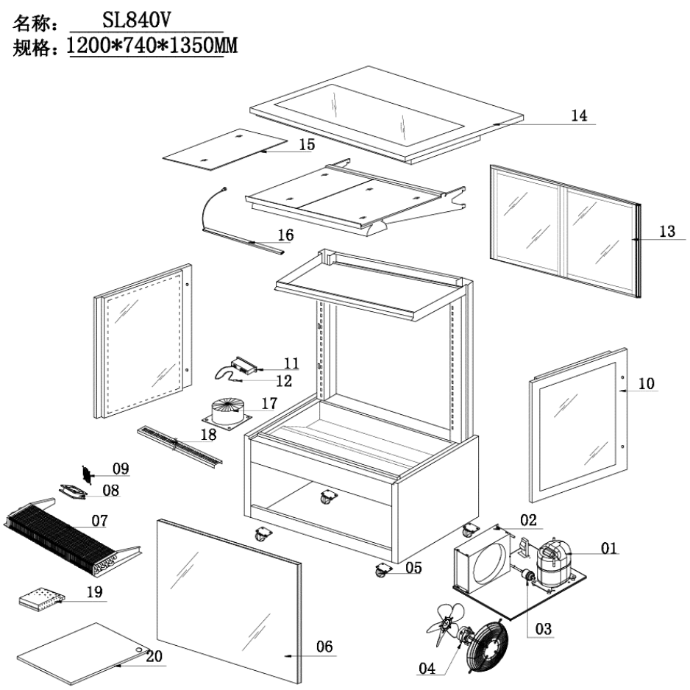
Item |  | FHE Part Code | Description | Qty | Remark
1* |  | SC15MFX | Compressor R134A | 1
2* | Version 1 | SL840V-7 | Condenser 3 X 8 X 500 | 1 | 2019 Version
2* | Version 2 | SL850V-7 | Condenser 4mm X 8mm X 500mm | 1 | 2024 Version
3* |  | Drier-1 | Filter Drier DML032S | 1
4* |  | SL830V-CM | Condenser Motor 31W | 2
5 | Version 1 | SLP830C-13 | Normal Castor 2 Inch | 4
5 | Version 2 | SLP830C-14 | Brake Castor 2 Inch | 4
6* |  | SL840V-1 | Front Square Glass 1128mm X 851mm | 1
7* |  | SL840V-6 | Evaporator 6mm X 4mm X 870mm | 1
8* | Version 1 | FAN-120X120MM | Metal Body Plastic Blade Fan EBM9656/B02 120mm X 120mm X 38mm | 3
8* | Version 2 | FAN-04 | Metal Body Plastic Blade Square Fan 120mm X 120mm X 38mm | 3
9 |  | SL830V-FC | Fan Cover 120mm X 120mm | 3
10* | Left | SL830V-2 | Left Side Glass 720mm X 858mm | 1
10* | Right | SL830V-2A | Right Side Glass 720mm X 858mm | 1
11* | Version 1 | TEMP CONT SF-212 | Temperature Controller SF-212 | 1 | 2019 Version
11* | Version 2 | TC-SF-172E | Temperature Controller SF-172E | 1 | 2024 Version
12 |  | SL830V-PW | Wire of Probe Black/White | 1
13 |  | SL840V-4 | Rear Sliding Door 510mm W X 788mm H | 2

Item |  | FHE Part Code | Description | Qty | Remark
14* |  | SL840V-3 | Top Glass 1175mm X 730mm | 1
15* |  | SL840V-14 | Black Glass Shelf 523mm X 350mm X 4mm | 6
16* | COLD | SG120FA-LED A | LED Light Cool White 876mm | 4
16* | WARM | SG120FA-LED | LED Light Warm White 876mm | 4
17* |  | SL840V-CTT | Cylindrical Type Transformer 250W 40V | 1
18 |  | SL840V-SSADP | Stainless Steel Air Duct Plate 1020mm X 77mm | 2
19* |  | SG-SL-LT-60W | LED Light Transformer 60W 12V 5A | 1
20 |  | SL840-BP | Bottom panel set, 2 pcs, 394*510mm | 1
 |  | SL830V-SSN | Shelf Screw And Nut
 |  | BPT-Side | Black Plastic Trim Left/Right Side 1 pcs
 |  | GG/SG-11 | Glass Flat Screw and Gasket
 |  | Plug-Socket-Set | Light Plug and Socket Set
 |  | SL840V-4A | Door Track
 |  | SL840V-5 | Shelf Support Complete (light & glass shelf incl.)
 |  | SL840V-50 | Wire Rack/Shelf 523mm X 350mm
 |  | SL840V-FP | Front Panel No Hole
 |  | SL-Drain Tube | Half-thread Drain Tube
 |  | TBPT-1200mm | Top Black Plastic Trim Suit 1200mm Long Machine

*Wearable parts

