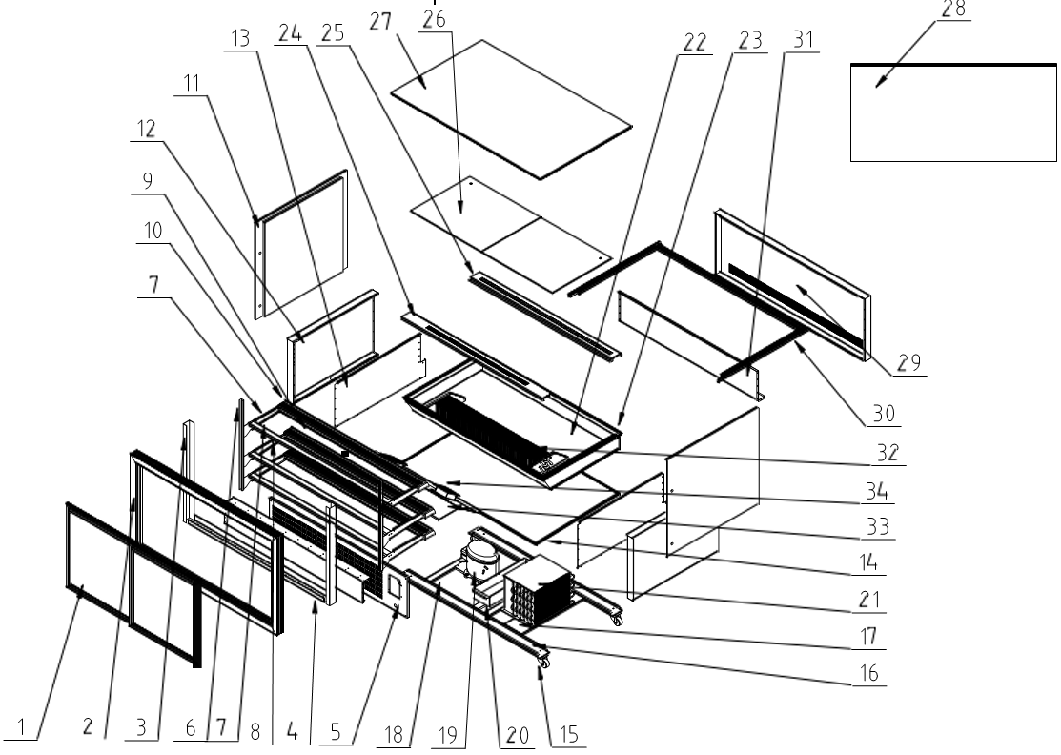
Item |  | FHE Part Code | Description | Qty | Remark
1* |  | GAN-1800RF3-HGSD | Hollow Glass Sliding Door | 1
2 |  | GAN-1800RF3-DF | Door Frame | 1
3 |  | GAN-1800RF3-CSP | Column Side Plate | 1
4 |  | GAN-1800RF3-DFBB | Bottom Bar of Door Frame | 1
5 |  | GAN-1800RF3-SP | Switch Panel | 1
6 |  | GAN-1800RF3-Ladder | Ladder | 1
7 |  | GAN-1800RF3-Support | Support | 3
8 |  | GAN-1800RF3-SBHB | Shelf Back Horizontal Bar | 2
9 |  | GAN-1800RF3-LC | Lamp Shade (aluminum alloy) | 2
10 |  | GAN-1800RF3-LEC | Lampshade End Cap (PVC) | 2
11* |  | GAN-1800RF3-SPG | Side Panel Glass | 1
12 |  | GAN-1800RF3-FFSP | Foam Frame Side Panel | 1
13 |  | GAN-1800RF3-FFSSP | Foam Frame Side Sealing Plate | 1
14 |  | GAN-1800RF3-FFOBP | Foam Frame Outside Base Plate | 1
15 |  | GAN-1500RF2-Castor | Castor/Wheel | 4
16 |  | GAN-1800RF3-BFSP | Bottom Frame Support Plate | 2
17 |  | GAN-1800RF3-CONSP | Condenser Support Plate | 1
18 |  | GAN-1800RF3-COMSP | Compressor Support Plate | 3
19* | Version 1 | SC12CNX.2 | Compressor R290 | 1 | SN From ZNZLY20201225GN1800RF3039  to ZNZL20231223GAN1800RF3017
19* | Version 2 | NUK120NA | Compressor R290 | 1 | SN From ZNZL20240821GAN1800RF3037
20 |  | GAN-1800RF3-WB | Water Box (PVC) | 1
21* |  | GAN-1800RF3-COND | Condenser | 1
22 |  | GAN-1800RF3-LA | Liner Assembly | 1
23 |  | GAN-1800RF3-FMF | Foam Mouth Frame | 1
24 |  | GAN-1800RF3-AO | Air Outlet | 1
25 |  | GAN-1800RF3-RAO | Return Air Opening | 1
26 |  | GAN-1800RF3-BP | Bottom Plate | 2
27* |  | GAN-1800RF3-RG | Roof Glass | 1

*Wearable parts
Item |  | FHE Part Code | Description | Qty | Remark
28* |  | GAN-1800RF3-FG | Front Glass 1775mm X 830mm | 1
29 |  | GAN-1800RF3-FFFP | Foam Frame Front Plate | 1
30 |  | GAN-1800RF3-GBF | Glass Bottom Frame (PVC) | 1
31 |  | GAN-1800RF3-FFFSP | Foam Frame Front Sealing Plate | 1
32* |  | GAN-1800RF-Evap | Evaporator 4 X 4 X 1410 | 1
33 |  | GAN-1800RF3-FB | Fan Board | 1
34* |  | GAN-1800RF3-EF | Evaporating Fan | 2
 |  | GAN-1800RF3-BTGS | Black Top Glass Shelf 248mm X 850mm
 |  | GAN-1800RF3-CRBP | Compressor Side Rear Bottom Panel
 |  | GAN-1800RF3-LRSD | Left Rear Sliding Door (Staff View) 840mm X 730mm H
 |  | GAN-1800RF3-RRSD | Right Rear Sliding Door (Staff View) 840mm X 730mm H
 |  | GAN-1800RF3-RSD | Rear Sliding Door Suit Unit Received On or After 18-12-2023
 |  | GAN-1800RF3-TG | Top Glass Suit GAN-1800RF3
 |  | GAN-1800RF-Light | LED Light SET/ ( 2PCS PER SET)
 |  | GAN-1500RF3-HT | Heater Transformer
 |  | GAN-1800RF2-BBGS | Black Bottom Glass Shelf 348mm X 850mm
 |  | GAN-1800RF2-BTGS | Black Top Glass Shelf 298mm X 850mm Same As GAN-1800RF3 Middle Shelf
 |  | GAN-RF3-TCRBP | Temp Controller Side Rear Bottom Panel
 |  | GN-RF-CC | Controller Cover
 |  | GAN-BDT | Bottom Door Track 2 Meters Cut To Size
 |  | GAN-CPS | Chrome Plated Strip 1.8m
 |  | GAN-DFBS | Door Frame Brush Seal
 |  | GAN-FGRS | Front Glass Rubber Seal Suit GAN Series Sold By Meter
 |  | GAN-TC | Carel Temperature Controller PJEZS1E0H
 |  | GAN-TCHA | Temp Controller Housing Assembly Includes Housing and 3 Switches
 |  | GAN-TDT | Top Door Track 2 Meters Cut To Size Same As Side Door Track

