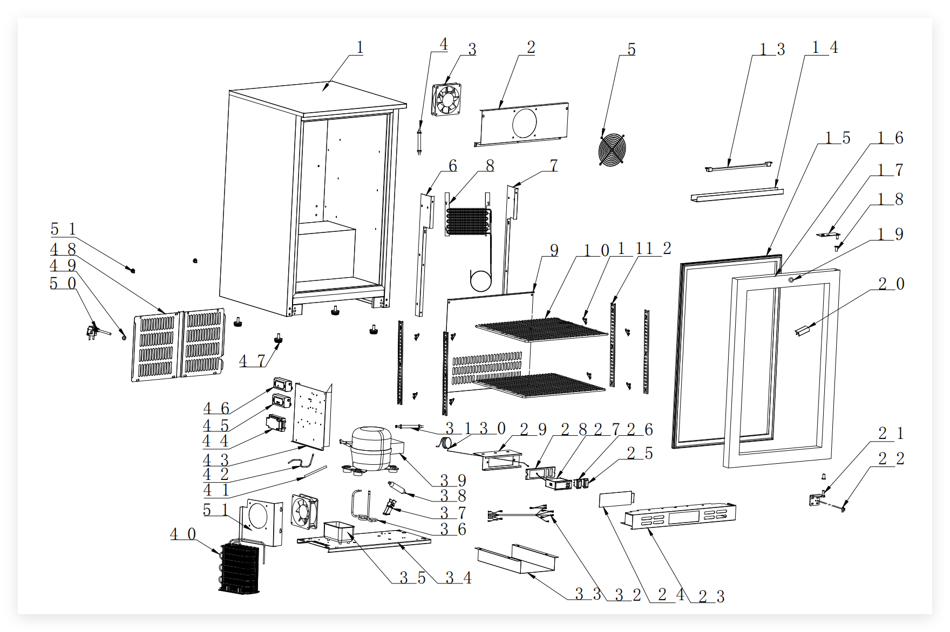
Item |  | FHE Part Code | Description | Qty | Remark
1 |  |  | Cabinet | 1
2 |  | F.203.001.208HA-001 | Fan Board | 1
3* |  | M.200.002.SDQ-SAD12038B12L-02/2 | Evaporator Fan DC 12V 0.27A SAD12038B12L | 2
4 |  | M.5L1.003.138HA-029 | Connective Wire | 1
5 |  | T.403.005.338FA-001 | Fan Cover | 1
6 |  | F.300.004.208HC-013-B | Left Ducting Bracket | 1
7 |  | F.300.004.208HC-014-B | Right Ducting Bracket | 1
8* |  | N.15B.002.138HA-008 | Evaporator | 1
9 |  | F.300.003.138HC-017 | Ducting Panel | 1
10* |  | P.107.138H-001 | Shelf | 2
11 |  | LG-1000E-17-New | New Smaller Shelf K Clip T.204.002.1000WBA-007 | 8
12 |  | T.202.001B.208HB-350-02 | K Strip | 4
13* |  | M.305.004.400-2835-30-01-B-SM(G) | LED Light 12V 2.9W White 400mm L | 1
14 |  | DZ.501.003.138HA-518-03 | Light Cover | 1
15* | Version 1 | DM.60H.138HC-005-H | Door Gasket | 1 | Interchangeable
15* | Version 2 | DM.60R.138HC-005-H | Door Gasket | 1 | Interchangeable
16* |  | LG138H-42 | Glass Door 750mm X 597mm C.02.006.138HC-039-H | 1

Item |  | FHE Part Code | Description | Qty | Remark
17* | Version 1 | LG138H-41 | Top Right Door Hinge T.402.003.208HA-032R-HZ | 1 | Interchangeable
17* | Version 2 | T.402.003.208HA-032R-HD | Top Right Door Hinge | 1 | Interchangeable
18 |  | DM.706.005.228FA-001-H | Door Shaft Sleeve | 2
19* |  | LG-208HC-LK | Lock and Key T.402.001.208HA-001 | 1
20* | Version 1 | LG138H-45 | Door Handle (Plastic) | 1 | SN From 20140912001 to 20170825024
20* | Version 2 | LG-330HC-DH | Door Handle (Metal) T.402.002.208HA-001-H | 1 | SN From 20170911001
21* |  | LG138H-41A | Bottom Right Door Hinge T.402.003.208HA-031-HD | 1
22 |  | T.402.007.330HA-002 | Iron Support Fastener | 1
23 |  | F.207.001.138HA-041R-HZ | Front Bottom Panel | 1
24 |  | DZ.708.008.208HA-007 | Protective Cover | 1
25* |  | M.302.001.208HA-003 | Power switch (Red) | 1
26* |  | LG138H-3 | Light Switch (Green) M.302.001.208HA-004 | 1
27* | Version 1 | LG138H-18 | Digital Thermostat Carel RCBHS1H0E1K | 1 | SN From 20140912001 to 20210730016
27* | Version 2 | M.401.002.ECS-16-01 | Digital Thermostat | 1 | SN From 20210901001
28 |  | DZ.708.008.208HA-005-H | LED Display Controller Cover | 1
29* |  | DZ.708.008.208HA-006-H | Temperature Gauge Board Assembly | 1
30* |  | M.401.002.ECS-16-2500 | Sensor | 1

Item |  | FHE Part Code | Description | Qty | Remark
31 |  | M.5L2.003.138HA-050 | Compressor Bundle | 1
32 |  | M.5L2.003.138HA-059 | Connect Wire for Digital Thermostat | 4
33 |  | T.403.010.208HA-011 | Strength metal for ventilation cover | 1
34 |  | F.201.001.138HA-011 | Compressor Supporter | 1
35 |  | DZ.708.003.138HA-001-H | Water tray | 1 | Same as LG138H-12
36 |  | N.300.002.138HA-006 | Venting Tube | 1
37 |  | DZ.708.010.1000WBA-004-H | Dryer Clip | 1
38 |  | LG-208HC-2 | Dry Filter N.101.228FA-001 | 1
39* | Version 1 | CMA057LHEG | Compressor R134a | 1 | SN From 20140912001 to 202101200010
39* | Version 2 | EKZ80L | Compressor M.10F.EKZ80L R600a | 1 | SN From 20210302001
40* |  | LG138H-6 | Condenser N.20C.138HA-010 | 1
41 | Version 1 | N.300.228FA-005 | Evaporator Pipe | 1 | Interchangeable
41 | Version 2 | N.300.003.208HA-001 | Evaporator Pipe | 1 | Interchangeable
42 |  | N.300.004.138HC-001 | Return Pipe | 1
43 |  | F.202.001.208HA-008 | Electronic Supporting Plate | 1
44 |  | DZ.708.005.660WA-001/2 | Connecting Box | 1
45* |  | LG-208SC-LT | LED Transformer RKPO-XX121000 110-240VAC 12VDC 1000mA | 1 | For Internal Light, Evaporator Fan

*Wearable parts
Item |  | FHE Part Code | Description | Qty | Remark
46* |  | LG-208SC-LT | LED Transformer RKPO-XX121000 110-240VAC 12VDC 1000mA | 1 | For Condenser Fan
47 |  | LG208H-Legs | Adjustable Leg DZ.708.004.208HA-002-H | 4
48 |  | F.208.001.138HA-013 | Rear Cover | 1
49 |  | T.203.001.001 | Wire Grommet | 1
50 | Version 1 | M.600.C2-075-2200-H | Plug | 1 | Before 12.22.2025
50 | Version 2 | M.600.E3-075-2200-H | Power Cord 10A 0.75mm² 2200mm Fork Terminal | 1 | After 12.22.2025
51 |  | F.300.008.138HA-006 | Fan Assembly Panel | 1
52 |  | DZ.708.004.BJ9A-001-H | Space Feet From Wall | 2
 |  | LG138H-30 | Lamp holder | 1

