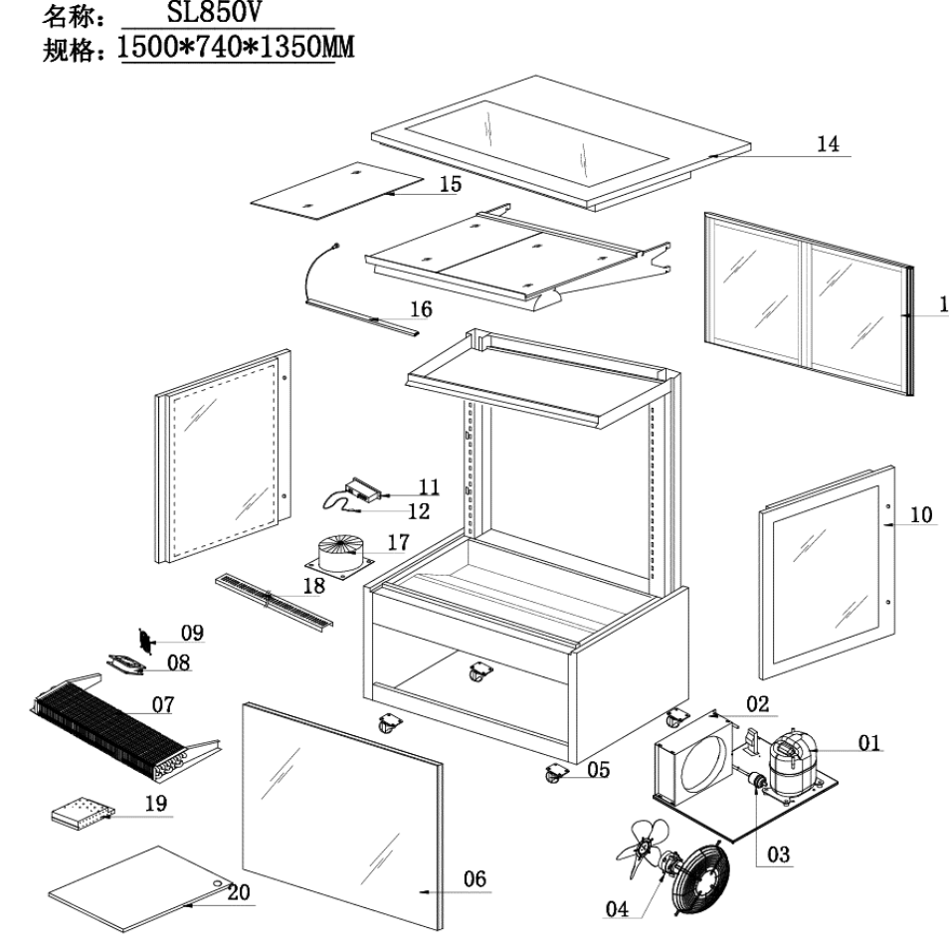
Item |  | FHE Part Code | Description | Qty | Remark
1* |  | SC18G | Compressor R134a | 1
2* |  | SL850V-7 | Condenser 4mm X 8mm X 500mm | 1
3* |  | Drier-1 | Filter Drier DML032S | 1
4* |  | SL830V-CM | Condenser Motor 31W | 2
5 | Version 1 | SLP830C-13 | Normal Castor 2 Inch | 4
5 | Version 2 | SLP830C-14 | Brake Castor 2 Inch | 4
6* |  | SL850V-1 | Front Square Glass 1428mm X 851mm | 1
7* |  | SL850V-6 | Evaporator 6mm X 4mm X 1170mm | 1
8* | Version 1 | FAN-120X120MM | Metal Body Plastic Blade Fan EBM9656/B02 120mm X 120mm X 38mm | 4
8* | Version 2 | FAN-04 | Metal Body Plastic Blade Square Fan 120mm X 120mm X 38mm | 4
9 |  | SL830V-FC | Fan Cover 120mm X 120mm | 4
10* | Left | SL830V-2 | Left Side Glass 720mm X 858mm | 1
10* | Right | SL830V-2A | Right Side Glass 720mm X 858mm | 1
11* | Version 1 | TEMP CONT SF-212 | Temperature Controller SF-212 | 1 | 2019 Version
11* | Version 2 | TC-SF-172E | Temperature Controller SF-172E | 1 | 2024 Version
12 |  | SL830V-PW | Wire of Probe Black/White | 1
13 |  | SL850V-4 | Rear Sliding Door 788mm H X 648mm W | 2
14* |  | SL850V-3 | Top Glass 1475mm X 730mm | 1

*Wearable parts
Item |  | FHE Part Code | Description | Qty | Remark
15* |  | SL850V-14 | Black Glass Shelf 675mm x 350mm x 6mm | 6
16* | COLD | SG150FA-LED A | LED Light Cool White 1180mm | 4
16* | WARM | SG150FA-LED | LED Light Warm White 1180mm | 4
17* |  | SL850V-CTT | Cylindrical Type Transformer 300W 50V | 1
18 |  | SL850V-SSADP | Stainless Steel Air Duct Plate 1320mm X 77mm | 2
19* |  | SG-SL-LT-98W | LED Light Transformer New Version 7A 98W | 1
20 |  | SL850V-BP | Bottom Panel Set 394mm X 660mm | 2
 |  | GG/SG-11 | Glass Flat Screw and Gasket
 |  | GG-SC-XB | BOTTOM END CAP
 |  | GG-SC-XT | TOPSHELF END CAP
 |  | SL850V-4A | Door Track
 |  | SL850V-FP | Front Panel
 |  | SL-Drain Tube | Half-thread Drain Tube
 |  | SL830V-SSN | Shelf Screw And Nut

