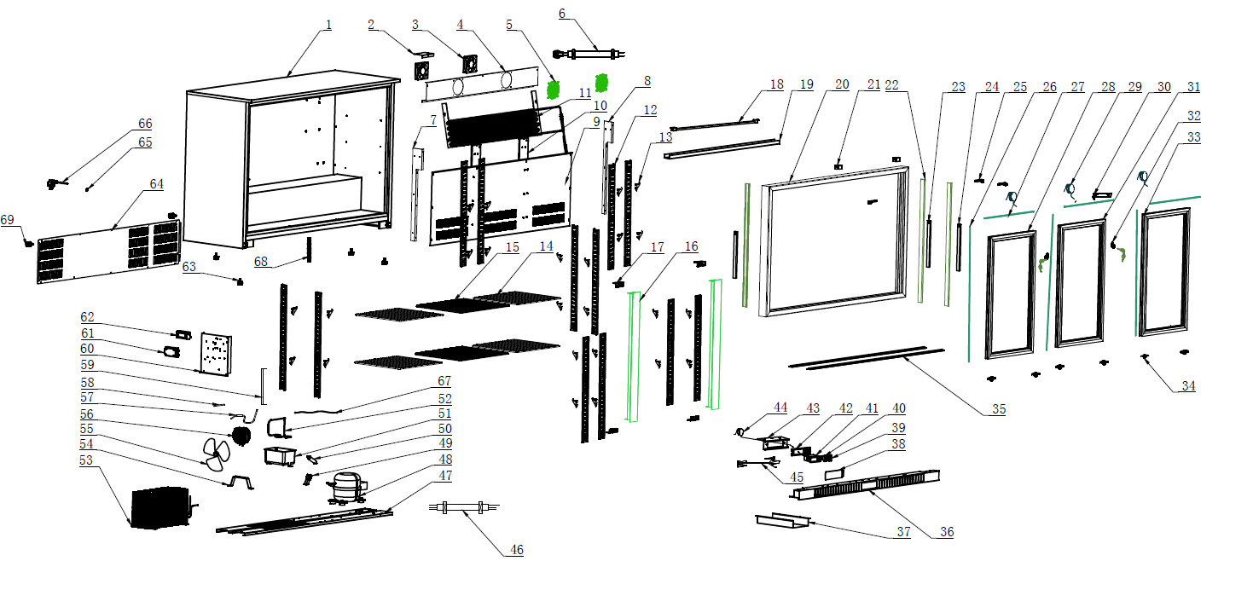
Item |  | FHE Part Code | Description | Qty | Remark
1 |  |  | Cabinet Assembly | 1
2 |  | F.300.004.248HC-005 | Ducting Board Bracket B | 1
3* |  | M.200.002.SDQ-SAD12038B12L-02/2 | Evaporator Fan DC 12V 0.27A SAD12038B12L | 2
4 |  | F.203.001.330HA-001 | Fan Board | 1
5 |  | T.403.005.338FA-001 | Evaporator Fan Cover | 2
6 |  | M.5L1.003.330HA-029 | Dc Motor Connection Cable | 1
7 | Version 1 | F.300.004.208HC-001-B | Support for air duct board | 1 | Interchangeable
7 | Version 2 | F.300.004.208HC-013-B | Support for Air Duct Board（Left） | 1 | Interchangeable
8 | Version 1 | F.300.004.208HC-002-B | Support for air duct board | 1 | Interchangeable
8 | Version 2 | F.300.004.208HC-014-B | Support for Air Duct Board（Right） | 1 | Interchangeable
9 | Version 1 | F.300.003.330HC-006 | Ducting Board | 1 | Interchangeable
9 | Version 2 | F.300.003.330HC-017 | Ducting Board | 1 | Interchangeable
10 | Version 1 | F.300.002.208HC-006-B | Support Panel for K-support | 2 | Interchangeable
10 | Version 2 | F.300.002.208HC-014-B | Support Panel for K-support | 2 | Interchangeable
11* | Version 1 | LG-330HC-Evap | Evaporator N.15B.002.330HA-003 | 1 | Interchangeable
11* | Version 2 | N.15B.002.330HA-008 | Evaporator | 1 | Interchangeable
12 |  | T.202.001B.208HC-334-02 | Support Panel for K-support | 12
13 |  | LG-1000E-17-New | New Smaller Shelf K Clip T.204.002.1000WBA-007 | 24

Item |  | FHE Part Code | Description | Qty | Remark
14* | Version 1 | P.107.002.208HA-008 | Left/Right shelf | 4 | Interchangeable
14* | Version 2 | LG330H-43 | Left/Right Shelf 345mm X 400mm P.107.208H-001 | 4 | Interchangeable
15* | Version 1 | P.107.002.330HA-008 | Middle shelf | 2 | Interchangeable
15* | Version 2 | LG330H-50 | Middle Shelf 345mm X 445mm P.107.330H-001 | 2 | Interchangeable
16 | Version 1 | C.03.002X.208HC-002A-HZ | Middle Pole Assembly | 2 | Non-Interchangeable
16 | Version 2 | C.03.002X.208HC-011-HZ | Middle Pole Assembly | 2 | Non-Interchangeable
17 | Version 1 | F.103.004.208HA-005 | Support Panel for Middle Pole Assembly | 4 | Interchangeable
17 | Version 2 | F.103.004.208HA-007 | Support Panel for Middle Pole Assembly | 4 | Interchangeable
18* | Version 1 | LG-330HC-Light | Light M.305.004.1100-2835-30-01-B-EL | 1 | Interchangeable
18* | Version 2 | M.305.004.1100-2835-30-01-B-SM | LED Light | 1 | Interchangeable
19 |  | DZ.501.003.330HA-1268-03 | Lamp Cover | 1
20 |  | C.07.330SC-001-H | Sliding Door Track Assembly | 1
21 |  | DZ.708.010.330SA-002 | Sliding Door Buffer Stopper | 2
22 |  | DZ.708.001.208SC-710-H | Sliding Door Frame Groove Seal | 3
23 |  | T.402.008.208SB-001-B | Counterweight Block | 3
25* |  | T.207.004.208SC-001 | Sliding Door Guide Roller | 3
26* |  | DM.706.003.MT-5*10-H | 5×10 Wool Pile Weatherstrip | 6
27* |  | DM.706.003.MT-5*5-H | 5×5 Wool Pile Weatherstrip | 6

Item |  | FHE Part Code | Description | Qty | Remark
28* | Version 1 | C.02.005.330SC-01LA-H-FB | Left Glass Door | 1 | Interchangeable
28* | Version 2 | C.02.006.330SC-05L-H-FB | Left Glass Door | 1 | Interchangeable
29 |  | T.205.005 | Nylon Rope | 3
30 |  | F.300.001.330SA-002-H | Sliding Door Limit Plate | 1
31* | Version 1 | C.02.005.330SC-01MA-H-FB | Middle Door Assembly | 1 | Interchangeable
31* | Version 2 | C.02.006.330SC-05M-H-FB | Middle Glass Door | 1 | Interchangeable
32 |  | T.402.001.208SA-001 | Key & Lock | 2
33* | Version 1 | C.02.005.330SC-01RA-H-FB | Right Door Assembly | 1 | Interchangeable
33* | Version 2 | C.02.006.330SC-05R-H-FB | Right Glass Door | 1 | Interchangeable
34 |  | E.402.208S-003 | Door Bottom Sliding Wheel | 6
35 |  | F.300.001.330SA-001 | Guide Rail | 2
36 | Version 1 | F.207.001.330SA-006-HZ | Front panel | 1 | Interchangeable
36 | Version 2 | F.207.001.330SA-015-HZ | Front panel | 1 | Interchangeable
37 |  | T.403.010.208HA-011 | Strength metal for ventilation cover | 1
38 |  | DZ.708.008.208HA-007 | Protective Cover | 1
39* |  | M.302.001.208HA-003 | Power switch (Red) | 1
40* |  | LG138H-3 | Light Switch (Green) M.302.001.208HA-004 | 1

Item |  | FHE Part Code | Description | Qty | Remark
41* | Version 1 | LG138H-18 | Digital Thermostat Carel RCBHS1H0E1K | 1 | SN From 20151203001 to 20210730007
41* | Version 2 | ECS-16 Temp Controller | Digital Thermostat | 1 | SN From 20210901001
42 |  | DZ.708.008.208HA-005-H | LED Display Controller Cover | 1
43 |  | DZ.708.008.208HA-006-H | Temperature Gauge Board Assembly | 1
44 |  | M.401.002.ECS-16-2500 | Temperature Probe Wire | 1
45 |  | M.5L2.003.330HA-059 | Connect Wire for Digital Thermostat | 1
46 |  | M.5L2.001.360FA-009 | Connect Wire for Compressor | 1
47 |  | F.201.001.330HA-013 | Compressor Supporter | 1
48* | Version 1 | EMT75HLP | Compressor R134a | 1 | SN From 20151203001 to 20210121010
48* | Version 2 | PZ99H1X | Compressor R600a M.10P.PZ99H1X | 1 | SN From 20210301001
49 |  | DZ.708.010.1000WBA-004-H | Dry Filter Clip | 1
50 |  | LG-208HC-2 | Dry Filter N.101.228FA-001 | 1
51 |  | DZ.708.003.660WA-001 | Water Tray | 1
52 |  | N.300.002.208HA-009 | Venting Tube | 1
53* |  | N.20C.330HA-007 | Condenser
54 |  | LG208H-8 | Condenser fan supporter T.403.003.208HA-003
55 |  | T.403.005.660WA-002 | Fan blade

*Wearable parts
Item |  | FHE Part Code | Description | Qty | Remark
56* |  | M.200.001.208HA-009/2 | Condenser Motor | 1
57 |  | N.300.004.138HC-001 | Evaporator Pipe | 1
58 | Version 1 | N.300.228FA-005 | Process Pipeline | 1 | Interchangeable
58 | Version 2 | N.300.003.208HA-001 | Process Pipeline | 1 | Interchangeable
59 |  | T.403.006.330HA-001 | Plate Support Frame | 1
60 |  | F.202.001.208HA-008 | Electronic Supporting Plate | 1
61 |  | LG208H-17 | Connecting Box DZ.708.005.660WA-001/2 | 1
62* |  | M.405.001.HS-EVS-A120150N-A0C-W1 | 12V Power Supply(18W) | 1
63 |  | LG208H-Legs | Adjustable Leg Dz.708.004.208ha-002-H | 4
64 | Version 1 | F.208.001.330HA-001 | Rear Panel | 1 | Interchangeable
64 | Version 2 | F.208.001.330HA-013 | Rear Panel | 1 | Interchangeable
65 |  | T.203.001.001 | Cable Grommet | 1
66 |  | M.600.E3-075-2200-H | Power Cord 10A 0.75mm² 2200mm L Fork Terminal | 1
67 |  | M.5L2.228FA-001 | Compressor Ground Wire | 1
68 |  | T.211.003.208HA-003-H | Inner Tank Drain Pipe | 1
69 |  | DZ.708.004.BJ9A-001-H | Space Feet From Wall | 1

