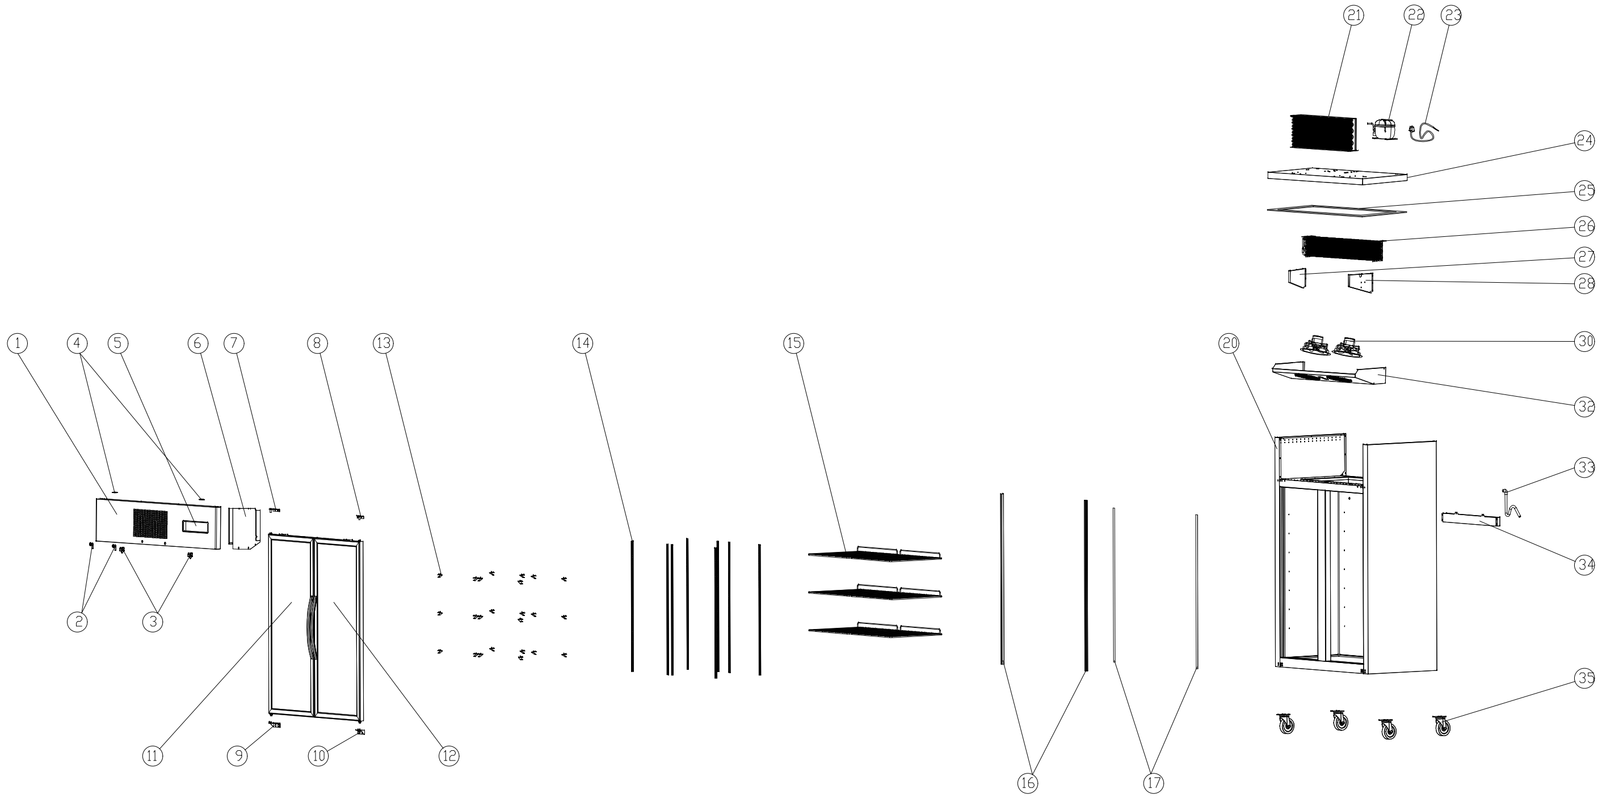
Item |  | FHE Part Code | Description | Qty | Remark
1 |  | SUFG1000B-TP | Top Panel | 1
2 |  | SUC/SUF-Key | Key & Lock Assembly | 2
3* |  | SUCG1000B-FS | Fan Switch | 2
4 |  | SUCG1000B-TCH | Top Cover Hinge | 2
5 |  | SUCG1000B-TCPP | Temperature Control Protection Panel | 1
6* |  | SUC-SUF-TCK | Touch Controller Kit | 1
7* |  | SUCG1500-TLDH-X | Top Left Door Hinge | 1
8* |  | SUCG1500-TRDH-X | Top Right Door Hinge | 1
9* |  | SUCG1500-BLDH-X | Bottom Left Door Hinge | 1
10* |  | SUCG1500-BRDH-X | Bottom Right Door Hinge | 1
11* |  | SUCG1000B-LD-X | Left Glass Door | 1
12* |  | SUCG1000B-RD-X | Right Glass Door | 1
13 |  | SUF600-20 | Shelf K Clip | 24
14 |  | SUCG1000B-KSS | K-type Seal Strip | 8
15* |  | SUF10A4.00-01 | Wire Shelf 530mm X 530mm | 6
16* |  | SUCG1000B-LSB | Lamp Shade Base | 2

Item |  | FHE Part Code | Description | Qty | Remark
17 |  | SUCG1000B-LTS | Light Transmitting Sheet | 2
20 |  |  | Cabinet Body | 1
21* |  | SUCG1000B-COND | Condenser | 1
22* |  | SC15MFX | Compressor R134A | 1
23 |  | SUCG1000B-PC | Power Cord | 1
24 |  | SUCG1000B-LCP | Lower Cover Plate | 1
25 |  | SUCG1000B-PEIC | PE Insulation Cotton | 1
26* |  | SUF1000-40 | Evaporator 5R6K680L | 1
27 |  | SUCG1000B-LEB | Left Evaporator Baffle | 1
28 |  | SUCG1000B-REB | Right Evaporator Baffle | 1
30* |  | SUCG1000B-EFMA | Evaporator Fan Motor Assembly | 2
32 |  | SUCG1000B-EFC | Evaporator Fan Cover | 1
33 |  | SUCG1000B-DP | Drain Pipe | 1
34 |  | SUCG1000B-EWT | Water Tray For Evaporator | 1
35 |  | SUF1000-NC-X | Normal Castor | 4
 |  | SUF1000-BC-X | Brake Castor | 4

*Wearable parts
Item |  | FHE Part Code | Description | Qty | Remark
 |  | SUF1000-PH | Pan/Drain Heater
 |  | Drier-1 | DRIER LIQUID LINE DML032S 1/4 SOLDER
 |  | SUCG1000-DG-X | Door Gasket
 |  | SUCG1000-CFM | Condenser Fan Motor
 |  | SG-SL-LT-98W | LED Light Transformer New Version 7A 98W

