Stainless Steel Counter

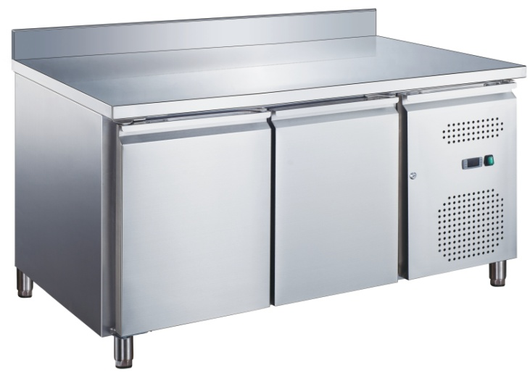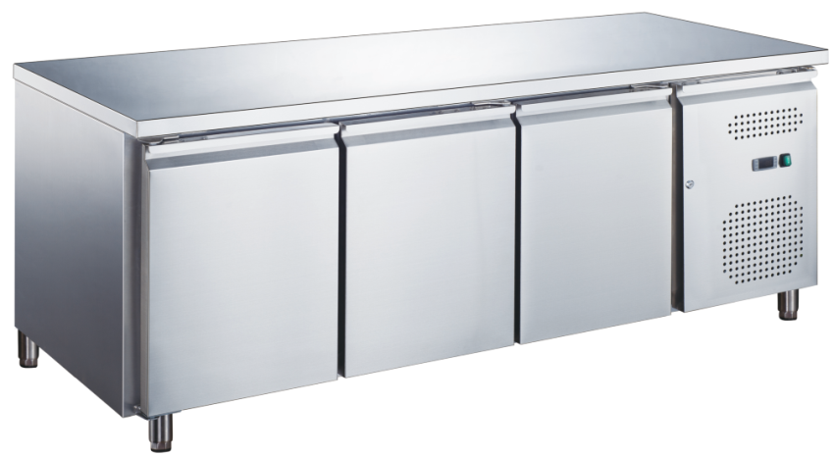

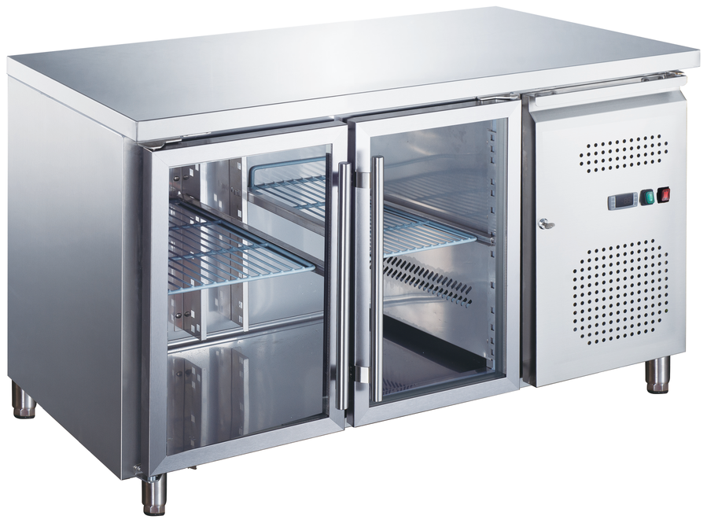

Installation,Operation & Maintenance Manual
(HC Gas R290 used)

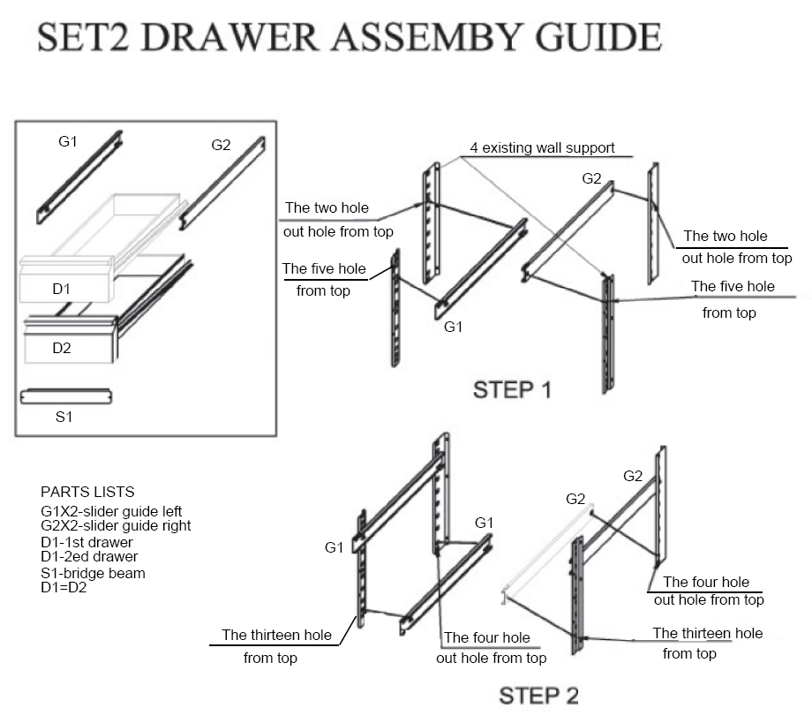

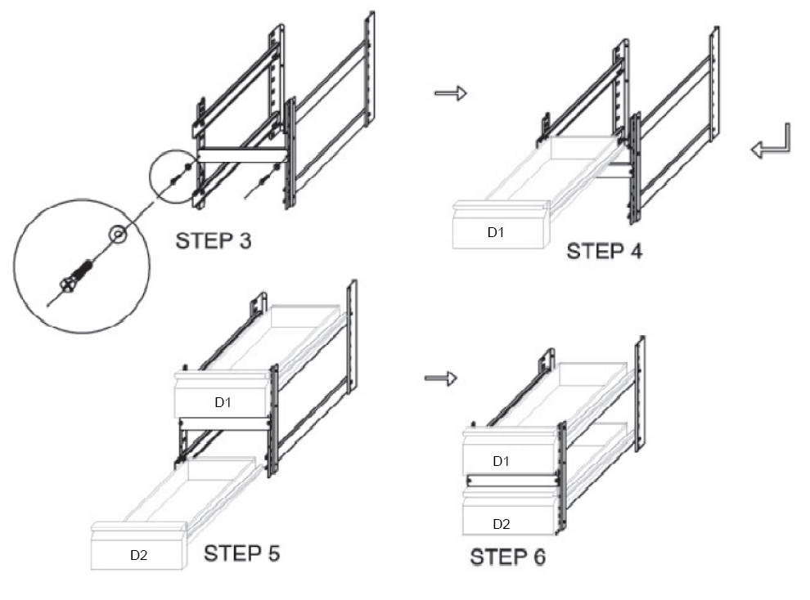

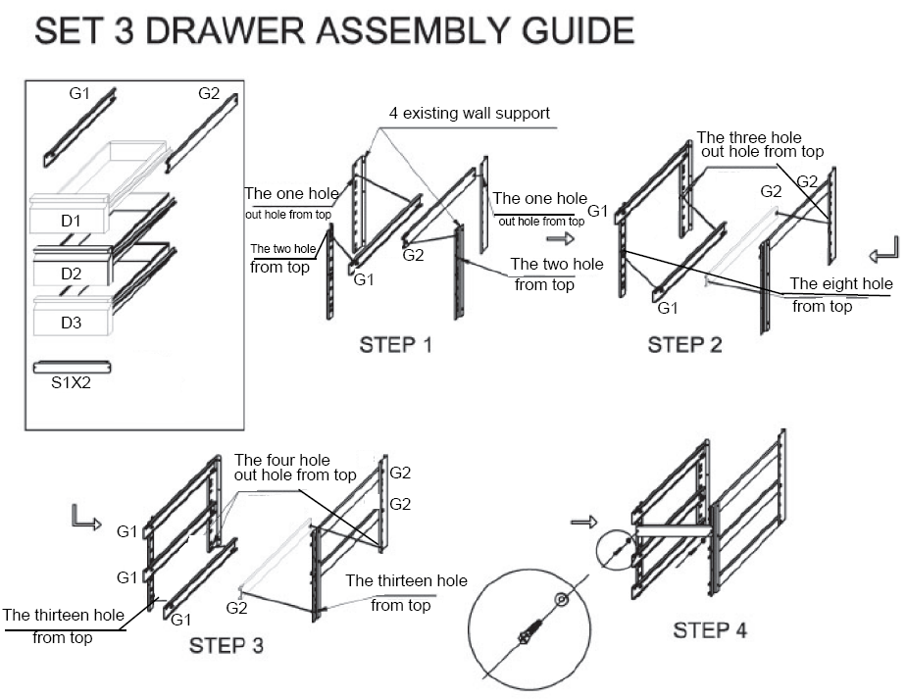

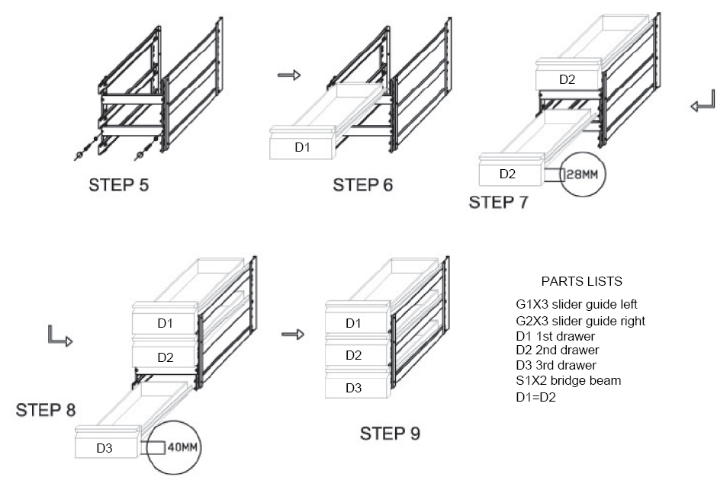

Safety Tips
- Position on a flat, stable surface.
- A service agent/qualified technician should carry out
installation and any repairs if required. Do not remove
any components or service panels on this product.
Consult Local and National Standards to comply with
The following:
·Health and Safety at Work Legislation
·BS EN Codes of Practice
·Fire Precautions
·IEE Wiring Regulations
·Building Regulations
- DO NOT use jet/pressure washers to clean the appliance.
- DO NOT use the appliance outside.
- DO NOT use this appliance to store medical supplies.
- DO NOT use electrical appliances inside the appliance.
(e.g. heaters, ice-cream makers etc.)
- DO NOT stand or support yourself on the base,
drawers or doors.
- DO NOT allow oil or fat to come into contact with the
plastic components or door seal. Clean immediately if
contact occurs.
- Bottles that contain a high percentage of alcohol must
be sealed and placed vertically in the refrigerator.
- Always carry, store and handle the appliance in a
vertical position and move by holding the base of the
appliance.
- Always switch off and disconnect the power supply to
the unit before cleaning.
- Keep all packing away from children. Dispose of the
packaging in accordance with the regulations of local
authorities.
- If the power cord is damaged, it must be replaced by
an agent or a recommended qualified technician in
order to avoid a hazard.
Introduction
Please take a few moments to carefully read through this
manual. Correct maintenance and operation of this
machine will provide the best possible performance from
your product.
Pack Contents
The following is included：
·Refrigerator or Freezer
·Shelf guides (2 per door)
·Shelves (1 per door)
·Instruction manual
We pride ourselves on quality and service, ensuring that
at the time of packing the contents are supplied fully
functional and free of damage. Should you find any
damage as a result of transit, please contact your dealer
immediately.
Installation
Note: If the unit has not been stored or move in an
upright position, let it stand upright for approximately
12 hours before operation. If in doubt allow to stand.
- Remove the appliance from the packaging. Make
sure that all protective plastic film and coatings
are thoroughly removed from all surfaces.
- Maintain a distance of 20 cm (7 inches) between
the unit and walls or other objects for ventilation
increase this distance if the obstacle is a heat source.

Note: Before using the appliance for the first time,
clean the shelves and interior with soapy water.

- Set the brakes on the castors to keep the appliance
in position OR level the appliance by adjusting the screw feet.

Fitting the Shelves
- Place one set of shelf guides on either side of the cabinet
at the desired height.
- Slide the shelf into place.
- Repeat for the remaining shelves.

Note: This is vital for ensuring correct drainage of condensation.

Operation
Storing Food
To get the best result from your appliance, follow these instruction:
·Only store foodstuffs in the appliance when it has reached the correct operating temperature.
·Do not place uncovered hot food or liquid inside the appliance.
·Warp or cover food where possible.
·Do not obstruct the fans inside the appliance.
·Avoid opening the doors for prolonged periods of time.
Turn on
- Close the door(s) of the appliance.
- Ensure the power switch is set to [O] and turn on at the socket.
- Switch on the power [l]. The current temperature within the
the appliance is displayed.

Manual Defrost
The appliance will automatically run a defrost cycle every six hours.

Note: The cycle starts from the time the appliance is initially powered up.

To manually defrost the appliance:
- Press and hold the DEFROST button for 5 seconds.
- The defrost cycle will start immediately and the Defrost
LET illuminates. The defrost will last a maximum of 30 minutes

Note: Starting a manual defrost also resets the automatic defrost timer.
- The next automatic defrost will start six hours after the manual
defrost has finished.

Cleaning, Care & Maintenance
- Switch off and disconnect from the power supply before cleaning.
- Clean the interior of the appliance as often as possible.
- Do not use abrasive cleaning agents. These can leave harmful residues.
- Clean the door seal with water only.
- Always wipe dry after cleaning.
- Do not allow water used in cleaning to run through the drain hole into the evaporation pan.
- Take care when cleaning the rear of the appliance. Sharp edges can cut.
· An agent or qualified technician must carry out repairs if required.
Cleaning the Condenser
Periodically cleaning the condenser can extend the life of the
appliance. We recommend that our agent or qualified technician clean the clean the condenser.

Troubleshooting
If your appliance develops a fault, please check the following table before making a call to your retailer.
Fault | Probable Cause | Action
The appliance is not working | The unit is not switch on | Check the unit is plugged in correctly and switched on
The appliance is not working | Plug and lead are damaged | Call your agent or qualified technician
The appliance is not working | Fuse in the plug has blown | Replace the fuse
The appliance is not working | Power supply | Check power supply
The appliance is not working | Internal wiring fault | Call your agent or qualified technician
The appliance turns on, but the temperature is too high/low | Too much ice on the evaporator | Defrost the appliance
The appliance turns on, but the temperature is too high/low | Condenser blocked with dust | Call your agent or qualified technician
The appliance turns on, but the temperature is too high/low | Doors are not shut properly | Check doors are shut and seals are not damaged
The appliance turns on, but the temperature is too high/low | Appliance is located near a heat source or air flow to the condenser is being interrupted | Move the refrigerator to a more suitable location
The appliance turns on, but the temperature is too high/low | Ambient temperature is too high | Increase ventilation or move appliance to a cooler position
The appliance turns on, but the temperature is too high/low | Unsuitable foodstuffs are being stored in the appliance | Remove any excessive hot foodstuffs or blockages to the fan
The appliance turns on, but the temperature is too high/low | Appliance is overloaded | Reduce the amount of food stored in the appliance
The appliance is leaking water | The appliance is not properly levelled | Adjust the screw feet to level the appliance(If applicable)
The appliance is leaking water | The discharge outside is blocked | Clear the discharge outlet
The appliance is leaking water | Movement of water to the drain is obstructed | Clear the floor of the appliance (if applicable)
The appliance is leaking water | The water container is damaged | Call your agent or qualified technician
The appliance is leaking water | The drip tray is over flowing | Empty the drip tray(if applicable)
The appliance is unusually loud | Loose nut/screw | Check and tighten all nuts and screws
The appliance is unusually loud | The appliance has not been installed in a level or stable position | Check installation position and change if necessary

Technical Specifications (R290)
Model | Voltage | Power  (W) | Current  (A) | Temperature  Range(℃) | Capacity  (litres) | Dimensions  HxWxD(mm) | Weight  (kg)
GX-GN2100TN-HC | 220～240V/50Hz | 215 | 1.3 | -2～+8 | 282 | 850x1360x700 | 102
GX-GN3100TN-HC | 220～240V/50Hz | 230 | 1.3 | -2～+8 | 417 | 850x1795x700 | 121
GX-GN4100TN-HC | 220～240V/50Hz | 345 | 2.0 | -2～+8 | 553 | 850x2230x700 | 150
GX-GN2200TN-HC | 220～240V/50Hz | 215 | 1.3 | -2～+8 | 282 | 950x1360x700 | 103
GX-GN3200TN-HC | 220～240V/50Hz | 230 | 1.3 | -2～+8 | 417 | 950x1795x700 | 134
GX-GN4200TN-HC | 220～240V/50Hz | 345 | 2.0 | -2～+8 | 553 | 950x2230x700 | 159
GX-GN2100TNG-HC | 220～240V/50Hz | 215 | 1.3 | +2～+8 | 282 | 850x1360x700 | 108
GX-GN3100TNG-HC | 220～240V/50Hz | 230 | 1.3 | +2～+8 | 417 | 850x1795x700 | 134
GX-GN4100TNG-HC | 220～240V/50Hz | 345 | 2.0 | +2～+8 | 553 | 850x2230x700 | 157
GX-GN2100BT-HC | 220～240V/50Hz | 520 | 3.2 | -18～-22 | 282 | 850x1360x700 | 107
GX-GN3100BT-HC | 220～240V/50Hz | 560 | 3.4 | -18～-22 | 417 | 850x1795x700 | 146
GX-GN4100BT-HC | 220～240V/50Hz | 650 | 4.0 | -18～-22 | 553 | 850x2230x700 | 160
GX-GN2200BT-HC | 220～240V/50Hz | 520 | 3.2 | -18～-22 | 282 | 950x1360x700 | 107
GX-GN3200BT-HC | 220～240V/50Hz | 560 | 3.4 | -18～-22 | 417 | 950x1795x700 | 159
GX-GN4200BT-HC | 220～240V/50Hz | 650 | 4.0 | -18～-22 | 553 | 950x2230x700 | 165
GX-SNACK2100TN-HC | 220～240V/50Hz | 215 | 1.3 | -2～+8 | 228 | 850x1360x600 | 88
Model | Voltage | Power  (W) | Current  (A) | Temperature  Range(℃) | Capacity  (litres) | Dimensions  HxWxD(mm) | Weight  (kg)
GX-SNACK3100TN-HC | 220～240V/50Hz | 230 | 1.3 | -2～+8 | 339 | 850x1795x600 | 122
GX-SNACK4100TN-HC | 220～240V/50Hz | 345 | 2 | -2～+8 | 449 | 850x2230x600 | 143
GX-SNACK2100TNG-HC | 220～240V/50Hz | 215 | 1.3 | +2～+8 | 228 | 850x1360x600 | 92
GX-SNACK3100TNG-HC | 220～240V/50Hz | 230 | 1.3 | +2～+8 | 339 | 850x1795x600 | 126
GX-SNACK4100TNG-HC | 220～240V/50Hz | 345 | 2 | +2～+8 | 449 | 850x2230x600 | 148
GX-SNACK2200TN-HC | 220～240V/50Hz | 215 | 1.3 | -2～+8 | 228 | 950x1360x600 | 91
GX-SNACK3200TN-HC | 220～240V/50Hz | 230 | 1.3 | -2～+8 | 339 | 950x1795x600 | 126
GX-SNACK4200TN-HC | 220～240V/50Hz | 345 | 2 | -2～+8 | 449 | 950x2230x600 | 146
GX-SNACK2100BT-HC | 220～240V/50Hz | 520 | 3.2 | -18～-22 | 228 | 850x1360x600 | 93
GX-SNACK3100BT-HC | 220～240V/50Hz | 560 | 3.4 | -18～-22 | 339 | 850x1795x600 | 126
GX-SNACK4100BT-HC | 220～240V/50Hz | 650 | 4 | -18～-22 | 449 | 850x2230x600 | 147
GX-SNACK2200BT-HC | 220～240V/50Hz | 520 | 3.2 | -18～-22 | 228 | 950x1360x600 | 93
GX-SNACK3200BT-HC | 220～240V/50Hz | 560 | 3.4 | -18～-22 | 339 | 950x1795x600 | 126
GX-SNACK4200BT-HC | 220～240V/50Hz | 650 | 4 | -18～-22 | 449 | 950x2230x600 | 147
GX-PA2100TN-HC | 220～240V/50Hz | 215 | 1.3 | -2～+8 | 390 | 850x1510x800 | 98
GX-PA3100TN-HC | 220～240V/50Hz | 320 | 1.9 | -2～+8 | 580 | 850x2020x800 | 152
GX-U-GN2100TN-HC | 220～240V/50Hz | 215 | 1.3 | -2～+8 | 172 | 650x1360x700 | 83
GX-U-GN3100TN-HC | 220～240V/50Hz | 230 | 1.3 | -2～+8 | 255 | 650x1795x700 | 120
GX-U-GN4100TN-HC | 220～240V/50Hz | 345 | 2 | -2～+8 | 337 | 650x2230x700 | 138
GX-SH2000/700-HC | 220～240V/50Hz | 320 | 1.9 | +2～+8 | 282 | 1085x1360x700 | 125
GX-SH2000/800-HC | 220～240V/50Hz | 320 | 1.9 | +2～+8 | 390 | 1085x1510x800 | 140
GX-SH3000/700-HC | 220～240V/50Hz | 320 | 1.9 | +2～+8 | 417 | 1085x1795x700 | 130
GX-SH3000/800-HC | 220～240V/50Hz | 320 | 1.9 | +2～+8 | 580 | 1085x2020x800 | 164
GX-PZ1610TN-HC | 220～240V/50Hz | 215 | 1.3 | -2～+8 | 390 | 1000x1515x800 | 262
GX-PZ2600TN-HC | 220～240V/50Hz | 215 | 1.3 | -2～+8 | 390 | 1000x1510x800 | 258
GX-PZ3600TN-HC | 220～240V/50Hz | 320 | 1.9 | -2～+8 | 580 | 1000x2020x800 | 320
GX-PZ2610TN-HC | 220～240V/50Hz | 215 | 1.3 | -2～+8 | 580 | 1000x2025x800 | 326
GX-GN2100SALGC-HC | 220～240V/50Hz | 215 | 1.3 | -2～+8 | 282 | 1365x1360x700 | 125
GX-GN3100SALGC-HC | 220～240V/50Hz | 230 | 1.3 | -2～+8 | 417 | 1365x1795x700 | 133
GX-GN4100SALGC-HC | 220～240V/50Hz | 345 | 2 | -2～+8 | 553 | 1365x2230x700 | 165

Electrical Wiring
Appliances are supplied with a 3 pin, moulded, BS1363 plug and lead, with a 13 amp fuse as standard. The plug is to be
connected to a suitable mains socket. Appliances are wired as follows:
·Live wire (coloured brown) to terminal marked L
·Neutral wire (coloured blue) to terminal marked N
·Earth wire (coloured green/yellow) to terminal marked E
All appliances must be earthed, using a dedicated earthing circuit.
If in doubt consult a qualified electrician.
Electrical isolation points must be kept clear of any obstructions. In the event of any emergency disconnection being
required they must be readily accessible.

R290 refrigerant is used for this equipment.
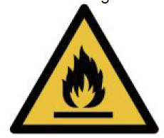
Caution!
Consult reprair manual/ower’s guide before attempting to install or service this product. All safety precautions must be followed. Dispose of properly in accordance with federal or local regulations. Risk of fire or explosion due to puncture of refrigerant tubing. Follow handling instructions carefully.
Danger!
Risk of fire or explosion. Flammable refrigerant used. To be repaired only by trained service personnel. Do not use mechanical devices to defrost refrigerator. Do not puncture refrigerant tubing.


Disposal
EU regulations require refrigeration product to be disposed of by specialist companies who remove or recycle all glasses,
metal and plastic components.
Consult your local waste collection authority regarding disposal of your appliance. Local authorities are not obliged to
dispose of commercial refrigeration equipment but may be able to offer advice on how to dispose of the equipment locally.
All packaging materials should be disposed of in an environmentally friendly way.
The cardboard may be used as scrap paper. The protective foil and the foam cushions are CFD-free.
Do not allow children to play with the packaging and destroy plastic gags safely.


Environmental protection
Discarded electric appliances are recyclable and should not be discarded in the domestic waste! Please actively support us in conserving resources and protecting the environment by returning this appliance to the collections centers (if available).

Compliance
Parts have undergone strict product testing in order to comply with regulatory standards and specification set by
international, independent, and federal authorities.
Products have been approved to carry the following symbol:


