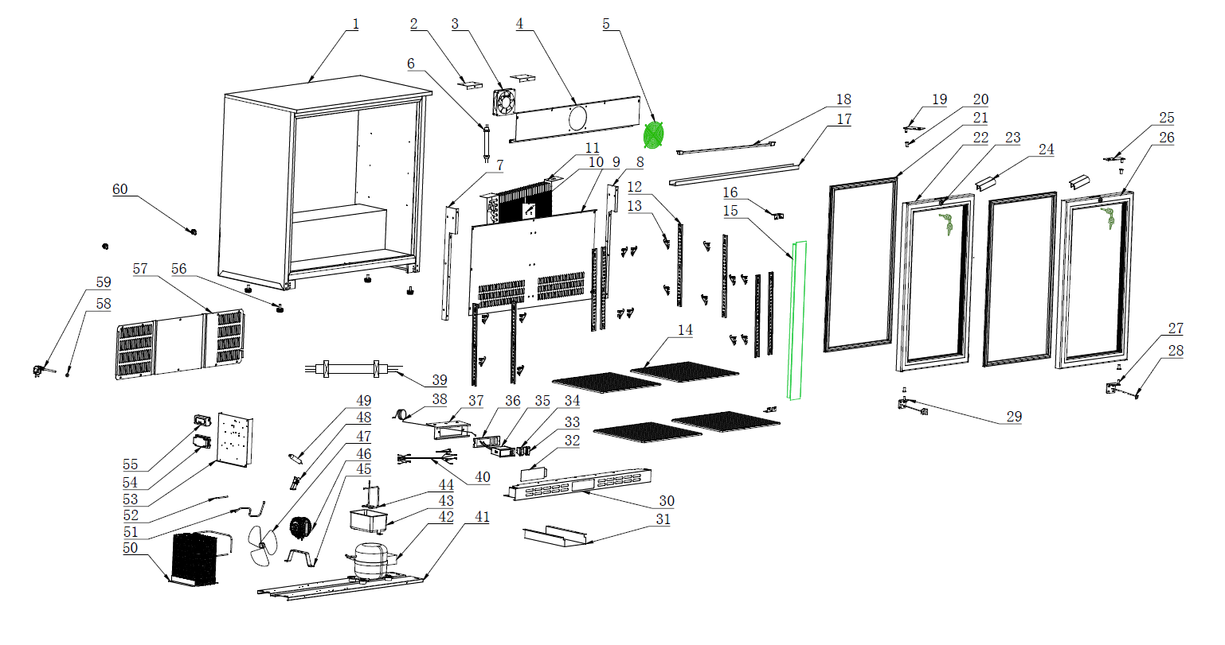
Item |  | FHE Part Code | Description | Qty | Remark
1 |  |  | Cabinet Assembly | 1
2 |  | F.300.004.248HC-005 | Ducting Board Bracket B | 1
3* |  | M.200.002.SDQ-SAD12038B12L-02/2 | Evaporator Fan DC 12V 0.27A SAD12038B12L | 1
4 |  | F.203.001.208HA-001 | Fan Board | 1
5 |  | T.403.005.338FA-001 | Evaporator Fan Cover | 1
6 |  | M.5L1.003.208HA-029 | Dc Motor Connection Cable | 1
7 | Version 1 | F.300.004.208HC-001-B | Support for Air Duct Board（Left） | 1 | Interchangeable
7 | Version 2 | F.300.004.208HC-013-B | Support for Air Duct Board（Left） | 1 | Interchangeable
8 | Version 1 | F.300.004.208HC-002-B | Support for Air Duct Board（Right） | 1 | Interchangeable
8 | Version 2 | F.300.004.208HC-014-B | Support for Air Duct Board（Right） | 1 | Interchangeable
9 | Version 1 | F.300.003.208HC-006 | Ducting Board | 1 | Interchangeable
9 | Version 2 | F.300.003.208HC-017 | Ducting Board | 1 | Interchangeable
10 | Version 1 | F.300.002.208HC-006-B | Support Panel for K-support | 1 | Interchangeable
10 | Version 2 | F.300.002.208HC-014-B | Support Panel for K-support | 1 | Interchangeable
11* | Version 1 | LG-208SC-41 | Evaporator N.15B.002.208HA-003 | 1 | Interchangeable
11* | Version 2 | N.15B.002.208HA-008 | Evaporator | 1 | Interchangeable
12 |  | T.202.001B.208HC-334-02 | Support Panel for K-support | 8
13 |  | LG-1000E-17-New | New Smaller Shelf K Clip T.204.002.1000WBA-007 | 16

Item |  | FHE Part Code | Description | Qty | Remark
14* |  | LG330H-43 | Left/Right Shelf 345mm X 400mm P.107.208H-001 | 4
15 | Version 1 | C.03.002X.208HC-002A-HZ | Middle Pole Assembly | 1 | Non-Interchangeable
15 | Version 2 | C.03.002X.208HC-011-HZ | Middle Pole Assembly | 1 | Non-Interchangeable
16 | Version 1 | F.103.004.208HA-005 | Support Panel for Middle Pole Assembly | 2 | Interchangeable
16 | Version 2 | F.103.004.208HA-007 | Support Panel for Middle Pole Assembly | 2 | Interchangeable
17 |  | DZ.501.003.208HA-818-03 | Lamp Cover | 1
18* | Version 1 | LG330H-32 | Light 14W (T5) 563 mm L 14W 6500K | 1 | Non-Interchangeable
18* | Version 2 | LG-208HC-Light | Light M.305.004.700-2835-30-01-B-EL | 1 | Interchangeable
18* | Version 3 | M.305.004.700-2835-30-01-B-SM | LED Light | 1 | Interchangeable
19* | Version 1 | LG-208HC-46-TLH | Top Door Hinge(left) T.402.003.208HA-032L-HZ | 1 | Interchangeable
19* | Version 2 | T.402.003.208HA-032L-HD | Top Door Hinge(left) | 1 | Interchangeable
20 |  | DM.706.005.228FA-001-H | Door Shaft Sleeve | 4
21* | Version 1 | LG-208HC-48 | Door Gasket 425mm X 730mm DM.60H.208HC-005-H | 2 | Interchangeable
21* | Version 2 | DM.60R.208HC-005-H | Door Gasket | 2 | Interchangeable
22* | Version 1 | LG-208HC-LD | Left Glass Door 751mm H X 446mm W C.02.006.208HC-019L-H | 1 | Interchangeable Before 20250318001
22* | Version 2 | C.02.006.208HC-029L-H | Left Glass Door with LOW E Outside | 1 | Interchangeable After 20250318001
23* |  | LG-208HC-LK | Lock & key T.402.001.208HA-001 | 2

Item |  | FHE Part Code | Description | Qty | Remark
24* | Version 1 | LG138H-45 | Door Handle (Plastic) | 2 | SN From 20140912001 to 20170825022
24* | Version 2 | LG-330HC-DH | Door Handle (Metal) T.402.002.208HA-001-H | 2 | SN From 20170911001
25* | Version 1 | LG138H-41 | Top Right Door Hinge T.402.003.208HA-032R-HZ | 1 | Interchangeable
25* | Version 2 | T.402.003.208HA-032R-HD | Top Right Door Hinge | 1 | Interchangeable
26* | Version 1 | LG-208HC-RD | Right Glass Door 751mm H X 446mm W C.02.006.208HC-019R-H | 1 | Interchangeable Before 20250318001
26* | Version 2 | C.02.006.208HC-029R-H | Right Glass Door with LOW E Outside | 1 | Interchangeable After 20250318001
27* |  | T.402.003.208HA-031-HD | Door Hinge Bottom Right Hand | 1
28 |  | T.402.007.330HA-002 | Iron Support Fastener | 2
29* |  | LG-208HC-46-BLH | Door Hinge Bottom Left Hand T.402.003.208HA-030-HD | 1
30 | Version 1 | F.207.001.208HA-011-HZ | Front Grill | 1 | Interchangeable
30 | Version 2 | F.207.001.208HA-041-HZ | Front Grill | 1 | Interchangeable
31 |  | T.403.010.208HA-011 | Strength metal for ventilation cover | 1
32 |  | DZ.708.008.208HA-007 | Protective Cover | 1
33* |  | M.302.001.208HA-003 | Power switch (Red) | 1
34* |  | LG138H-3 | Light Switch (Green) M.302.001.208HA-004 | 1
35* | Version 1 | LG138H-18 | Digital Thermostat Carel RCBHS1H0E1K | 1 | SN From 20140912001 to 20210730046
35* | Version 2 | M.401.002.ECS-16-01 | Digital Thermostat | 1 | SN From 20210901001

Item |  | FHE Part Code | Description | Qty | Remark
36 |  | DZ.708.008.208HA-005-H | LED Display Controller Cover | 1
37 |  | DZ.708.008.208HA-006-H | Temperature Gauge Board Assembly | 1
38 |  | M.401.002.ECS-16-2500 | Temperature Probe Wire | 1
39 |  | M.5L2.001.360FA-009 | Connect Wire for Compressor | 1
40 |  | M.5L2.003.208HA-059 | Connect Wire for Digital Thermostat | 1
41 |  | F.201.001.208HA-013 | Compressor Supporter | 1
42* | Version 1 | EMT75HLP | Compressor R134a | 1 | SN From 20140912001 to 20210121030
42* | Version 2 | PZ99H1X | Compressor R600a M.10P.PZ99H1X | 1 | SN From 20210302001
43 |  | DZ.708.003.660WA-001 | Water Tray | 1
44 |  | N.300.002.208HA-009 | Venting Tube | 1
45 |  | T.403.003.208HA-003 | Condenser Bracket | 1
46* |  | M.200.001.208HA-009/2 | Condenser Motor | 1
47 |  | T.403.005.660WA-002 | Fan Blade | 1
48 |  | DZ.708.010.1000WBA-004-H | Dry Filter Clip | 1
49 |  | LG-208HC-2 | Dry Filter N.101.228FA-001 | 1
50* |  | N.20C.208HA-007 | Condenser | 1
51 |  | N.300.004.138HC-001 | Evaporator Pipe | 1

*Wearable parts
Item |  | FHE Part Code | Description | Qty | Remark
52 | Version 1 | N.300.228FA-005 | Process Pipeline | 1 | Interchangeable
52 | Version 2 | N.300.003.208HA-001 | Process Pipeline | 1 | Interchangeable
53 |  | F.202.001.208HA-008 | Electronic Supporting Plate | 1
54 |  | DZ.708.005.660WA-001/2 | Connecting Box | 1
55* |  | M.405.001.HS-EVS-A120150N-A0C-W1 | 12V Power Supply(18W) | 1
56 |  | LG208H-Legs | Adjustable Leg DZ.708.004.208HA-002-H | 4
57 | Version 1 | LG-208HC-RP | Rear Panel F.208.001.208HA-006 | 1 | Interchangeable
57 | Version 2 | F.208.001.208HA-013 | Rear Panel | 1 | Interchangeable
58 |  | T.203.001.001 | Cable Grommet | 1
59 |  | M.600.E3-075-2200-H | Power Cord 10A 0.75mm² 2200mm Fork Terminal | 1
60 |  | DZ.708.004.BJ9A-001-H | Space feet from wall | 2

