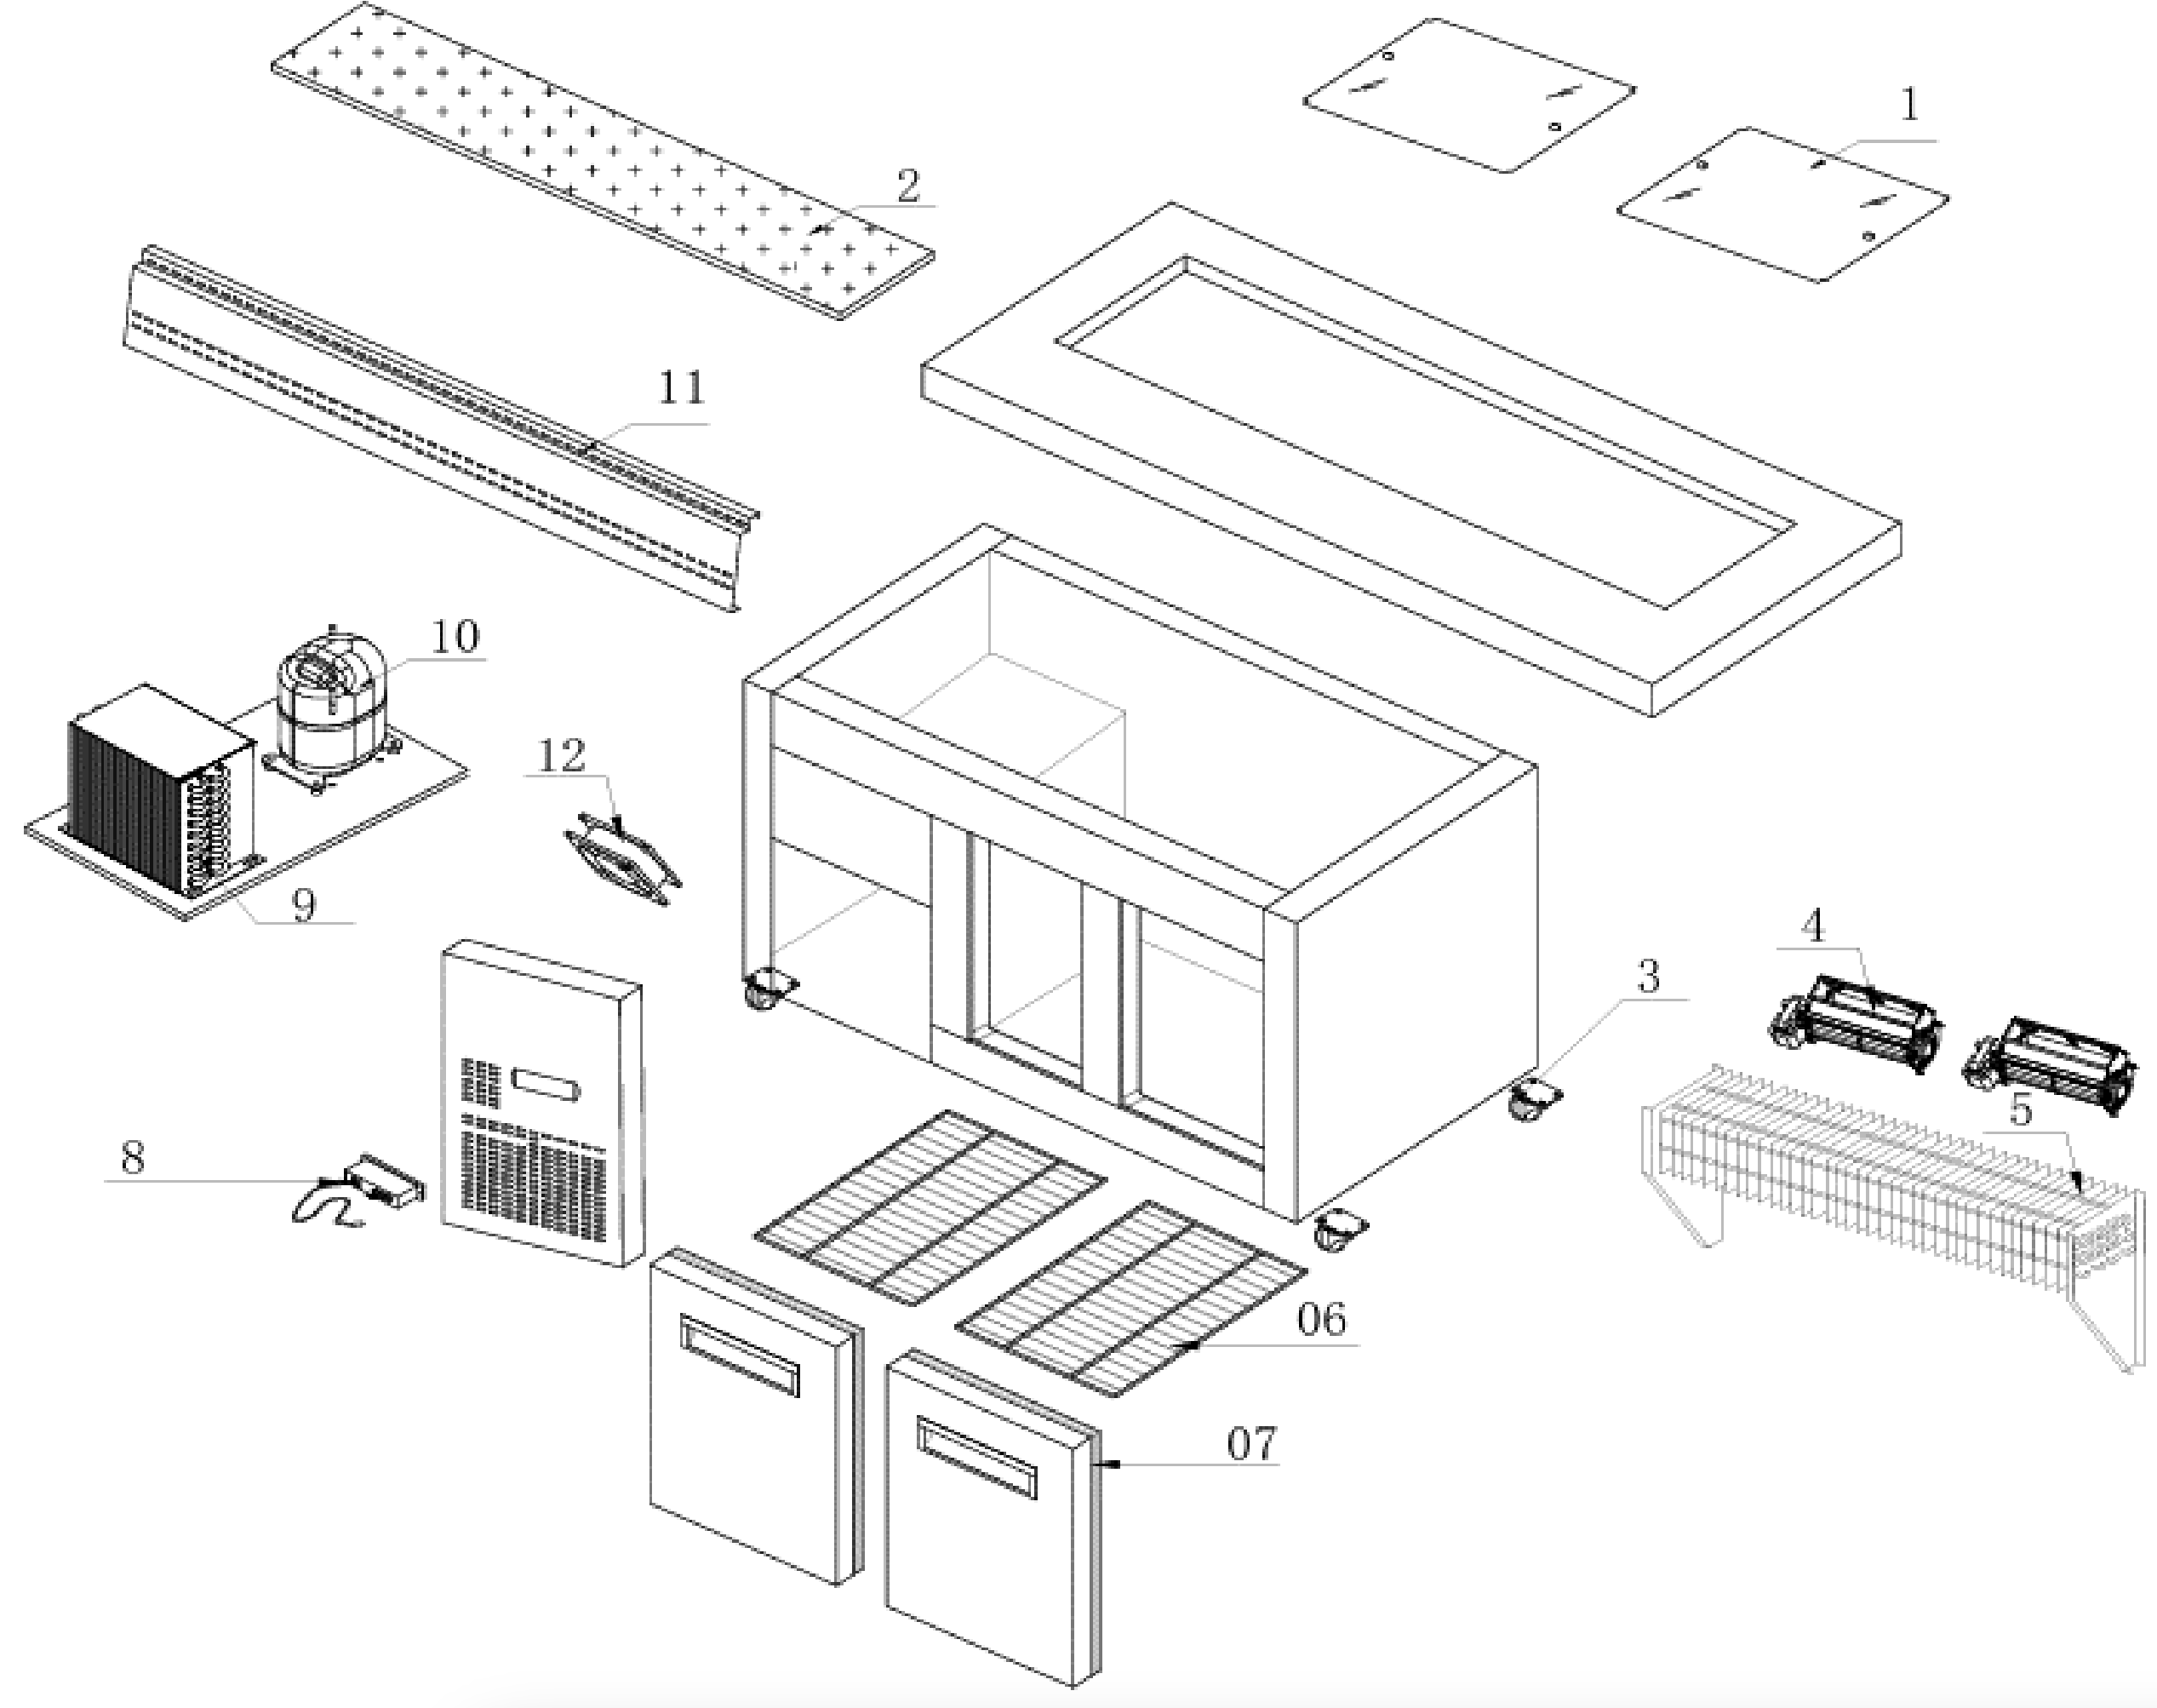
Item |  | FHE Part Code | Description | Qty | Remark
1 |  | PG180FA-XB-PSDS | Perspex Sliding Doors Set  435mm X 557mm 2 Pcs + 435mm X 586mm 2 Pcs | 1
2 |  | PG180FA-XB-CB | Chopping Board 1800mm X 220mm | 1
3 |  | PG150FE-11 | Normal Castor 3 Inch | 2
3 |  | PG150FE-11A | Brake Castor 3 Inch | 2
4 | Version 1 | FAN-04 | Metal Body Plastic Blade Square Fan 120mm X 120mm X 38mm | 3 | SN From 384102 to 385593
4 | Version 2 | PG180FA-XB-EF | Evaporator Cross Flow Fan Weiguang YGF60-183 | 2 | SN From 385782
5 |  | PG180FA-XB-Evap | Evaporator 5 X 4 X 1000 | 1
6 |  | PG180FB-XB-Shelf | Shelf 632mm X 500mm | 2
7 |  | PG180FA-XB-DG | Door Gasket 665mm X 645mm | 2
8 |  | TEMP CONT SF-102 | Temp Controller SF102 | 1
9 |  | PG180FA-XB-Cond | Condenser 3 X 11 X 280 | 1
10 |  | SF15MFX | Compressor | 1
11 |  |  | Air Duct Panel 1677mm X 200mm | 1
12 |  | FAN-24 | Fan SJ1225HA2 120mm X 120mm X 25mm 220V-240V AC 0.1A | 1
 |  | PG150FA-XG-CBFB | Chopping Board Fixing Bracket Set

Item |  | FHE Part Code | Description | Qty | Remark
 |  | PG180FA-XB-LD | Left Door 670mm X 650mm
 |  | PG180FA-XB-RD | Right Door 670mm X 650mm
 |  | PG180FE-XG-PD | Pan Divider 535mm X 40mm
 |  | PG150-PERSPEX COVER | Perspex Cover Set 460mm X 557mm  (2 PCS) + 460mm X 586mm (1 PC)

