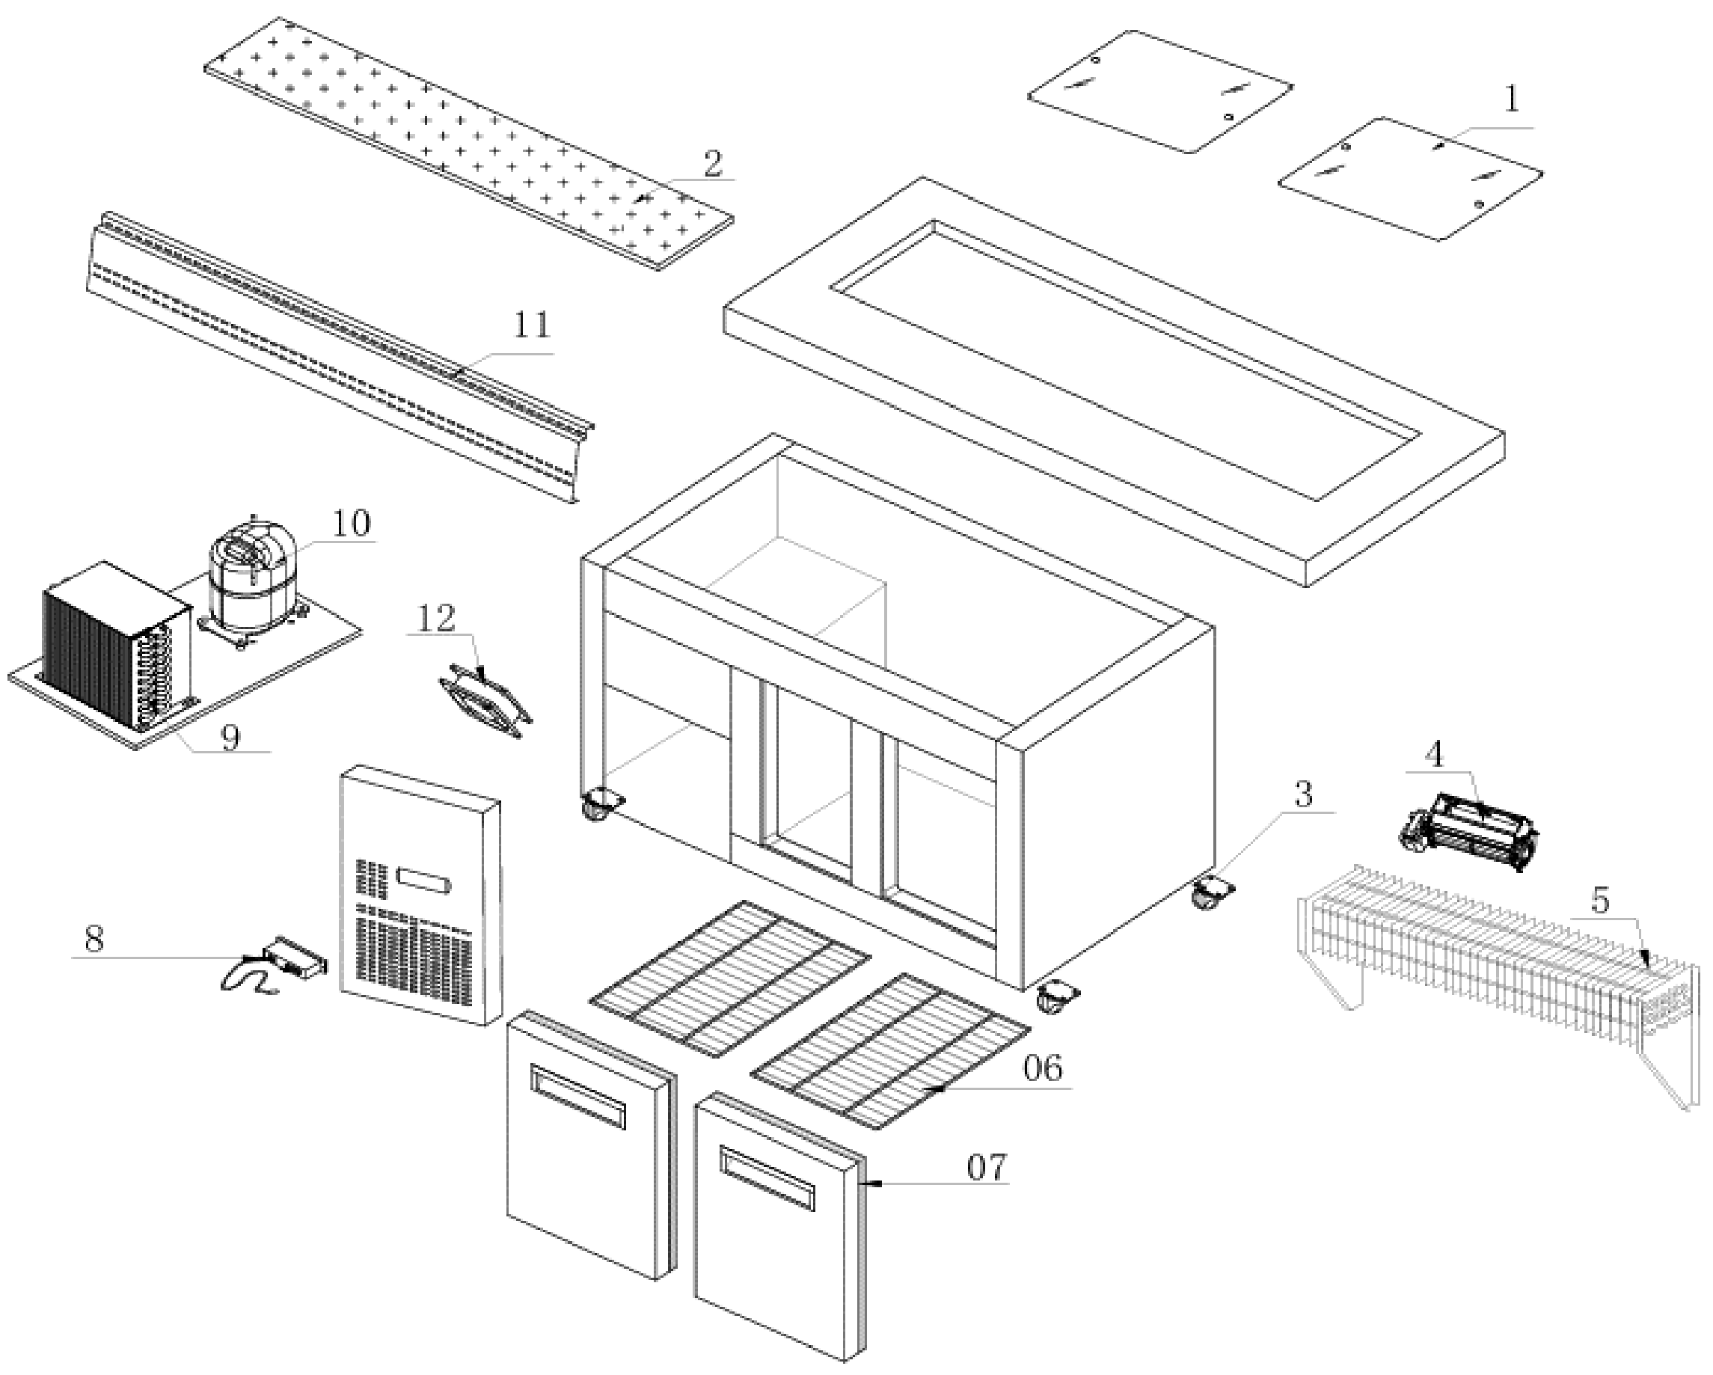
Item |  | FHE Part Code | Description | Qty | Remark
1 | 1-1 | PG150FA-XB-ASD557 | Acrylic Sliding Door 557mm X 460mm | 2
1 | 1-2 | PG150FA-XB-ASD586 | Acrylic Sliding Door 586mm X 460mm | 1
2 |  | PG150FA-XG-CB | Chopping Board 1460mm X 220mm | 1
3 |  | PG150FE-11 | Normal Castor 3 Inch | 2
3 |  | PG150FE-11A | Brake Castor 3 Inch | 2
4 | Version 1 | PG150FA-XG-EF | Evaporator Fan 120mm X 120mm | 3 | SN From 385175 to 385411
4 | Version 2 | PG180FA-XB-EF | Evaporator Cross Flow Fan Weiguang YGF60-183 | 1 | SN From 385778
5 |  | PG150FA-XG-Evap | Evaporator 5 X 4 X 700 | 1
6 |  | PG150FA-XG-Shelf | Left/Right Side Shelf 462mm X 500mm | 2
7 |  | PG150FA-XG-DG | Door Seal 495mm X 645mm | 2
8 |  | TEMP CONT SF-102 | Temp Controller SF102 | 1
9 |  | PG180FA-XB-Cond | Condenser 3 X 11 X 280 | 1
10 |  | SF15MFX | Compressor | 1
11 |  |  | Air Duct Panel 1337mm X 200mm | 1
12 |  | FAN-24 | Fan SJ1225HA2 120mm X 120mm X 25mm 220V-240V AC 0.1A | 1
 |  | PG150FA-XG-CBFB | Chopping Board Fixing Bracket Set

Item |  | FHE Part Code | Description | Qty | Remark
 |  | PG150FA-XG-CUP | Cooling Unit Panel
 |  | PG150FA-XG-LD | Left Door 500mm X 650mm
 |  | PG150FA-XG-RD | Right Door 500mm X 650mm
 |  | PG150FE-XG-PD | Pan Divider 535mm X 30mm
Perspex Cover Set 460mm X 557mm
(2 PCS) + 460mm X 586mm (1 PC)

